Table of Contents

References 8

25th May 9

CHI square test 9

Introduction to ML 9

Types of ML algorithms 9

Supervised Learning 9

Unsupervised Learning 10

Reinforcement Learning 12

Key Concepts in Reinforcement Learning 12

Types of Reinforcement Learning 12

Key Algorithms in Reinforcement Learning 13

Workflow of a Reinforcement Learning Task 13

Examples of Applications of Reinforcement Learning 13

26th May 14

Linear Regression 14

Linear Regression in Machine Learning 14

Types of Linear Regression 14

Key Components 14

Objective 14

Mathematical Representation 14

Assumptions 15

Sum of Square Errors (SSEs) 15

Mean Square Error (MSE) 16

Why Use MSE? 16

Interpretation of MSE 16

1st June 17

2nd June 17

8th June 17

Linear Regression 17

**Homoscedasticity** and **Heteroscedasticity** 20

Homoscedasticity 21

Heteroscedasticity 21

Example in Simple Linear Regression 22

Multicollinearity in Regression Analysis 22

Effects of Multicollinearity 23

Diagnosing Multicollinearity 23

9th June 25

Naive Model 25

Adjusted R-squared 25

Logistic Regression 26

Measure of Spread 28

15th June 30

Startify attribute 30

Importance of Stratification 30

How Stratification Works 30

Usage Example in Python with train_test_split 30

Output Explanation 31

When to Use Stratification 31

Summary 31

random_state attribute 31

Why Use random_state? 31

How random_state Works 31

fit_transform vs transform 32

fit_transform 32

When to Use fit_transform 32

transform 32

When to Use transform 32

Summary 32

Decision Trees 33

1. Concept and Structure 33

2. How Decision Trees Work 33

3. Advantages and Disadvantages 33

4. Pruning 34

5. Important Parameters 34

6. Ensemble Methods 34

Occam's Razor Principle 34

Origin and Explanation 34

Application in Science and Machine Learning 35

Examples 35

Mathematical Formulation 35

Practical Considerations 35

Summary 35

16th June 36

Overfitting vs Underfitting 36

Overfitting 36

Underfitting 36

Balancing Overfitting and Underfitting 37

Entropy 37

Conclusion 39

Random Forest 39

Key Concepts 39

How Random Forest Works 40

Advantages 40

Disadvantages 40

Hyperparameters 40

Example in Python (scikit-learn) 41

Conclusion 41

22nd June 44

Bias vs variance Error 44

Bias Error 44

Variance Error 45

Techniques to Address Bias and Variance 45

Synthetic Data 45

1. What is Synthetic Data? 45

2. Uses of Synthetic Data in ML 45

3. Generating Synthetic Data 46

4. Advantages of Synthetic Data 46

5. Challenges and Considerations 46

Summary 46

Oversampling and Undersampling 46

Oversampling 47

Methods of Oversampling 47

Advantages of Oversampling 47

Disadvantages of Oversampling 47

Undersampling 47

Methods of Undersampling 47

Advantages of Undersampling 48

Disadvantages of Undersampling 48

Choosing Between Oversampling and Undersampling 48

Practical Tips 48

Confusion Matrix 49

Structure of a Confusion Matrix 49

Key Terms 49

Metrics Derived from the Confusion Matrix 49

**Accuracy** 49

**Precision** (Positive Predictive Value) 49

**Recall** (Sensitivity or True Positive Rate) 50

F1 Score 50

**Specificity** (True Negative Rate) 50

False Positive Rate (FPR) 50

False Negative Rate (FNR) 50

Example 50

Importance of the Confusion Matrix 51

Accuracy Score vs ROC_AUC_Score 51

Accuracy Score 51

Advantages 51

Disadvantages 51

ROC AUC Score 51

Components 52

Advantages 52

Disadvantages 52

When to Use Each Metric 52

Summary 52

Naive Bayes algorithm 53

23rd June 54

CountVectorizer 54

K-Means algorithm 54

How K-Means Algorithm Works 54

Detailed Steps 55

Choosing the Number of Clusters (k) 55

**Elbow Method** 55

**Silhouette Score** 56

Advantages and Disadvantages 57

Advantages: 57

Disadvantages: 57

Conclusion 57

K-Means++ 57

How K-Means++ Works 57

Benefits of K-Means++ 58

Conclusion 58

29th June 59

K-Means Algorithm Applications 59

K-Means Clustering Drawbacks 59

1. Choosing the Number of Clusters (K) 59

2. Sensitivity to Initialization 59

3. Assumption of Spherical Clusters 60

4. Sensitivity to Outliers 60

5. Scalability 60

6. Cluster Assumption 60

7. Interpretability 60

8. Data Preprocessing Requirements 60

9. Cluster Size Imbalance 60

10. Non-deterministic Results 61

11. Computational Complexity 61

Hierarchical Clustering 61

Agglomerative Hierarchical Clustering 61

Steps: 61

Divisive Hierarchical Clustering 61

Steps: 61

Proximity Matrix 62

Construction of a Proximity Matrix 62

Dendrogram 63

Advantages 63

Disadvantages 63

Applications 63

30th June 64

Linkage 64

Metric 64

Association Rule Mining 64

Key Concepts 64

Example 65

Process of Association Rule Mining 65

Algorithms 66

6th July 67

Dimensionality Reduction 67

Principal Component Analysis 67

Key Concepts 67

Steps in PCA 67

Applications of PCA 68

Advantages and Disadvantages 68

Projection of a Data Point 68

Steps to Project a Data Point 69

7th July 70

Linear Discriminant Analysis 70

Overview of LDA 72

How LDA Works 72

PCA vs LDA 72

13th July 73

Covariance 73

Eigenvalues and Eigenvectors in PCA 73

Step-by-Step Explanation 73

Example 74

Why This Matters 75

14th July 76

Variance 76

Classification Report 77

Generating a Classification Report 77

Example Output 77

Interpretation 77

Full Code Example 78

Confusion Matrix 79

Structure of a Confusion Matrix 79

Precision 79

Formula 79

Interpretation 80

Summary 80

Recall 80

Formula 80

Interpretation 80

Summary 80

Accuracy 81

Formula 81

Interpretation 81

Summary 81

20th July 81

21st July 81

27th July 82

Time Series Data 82

Data Patterns 83

Rolling Mean 83

Types of Rolling Mean 83

Purpose and Applications 84

Rolling Standard Deviation 84

Purpose and Applications 84

Calculation 84

ARIMA model 85

Components of ARIMA 86

ARIMA Model Notation 86

Steps to Build an ARIMA Model 86

Example 86

Benefits of ARIMA 87

Adfuller Test 87

Key Concepts 87

Test Statistics 87

Steps to Perform the ADF Test 87

Example 88

Summary 88

28th July 88

3rd August 88

ACF(q) vs PACF(p) 88

1. Autocorrelation Function (ACF) 88

2. Partial Autocorrelation Function (PACF) 89

Usage in Machine Learning 89

4th August 89

**Decomposition** 89

Key Components of Time Series Decomposition 89

Types of Decomposition 90

Use Cases of Decomposition 90

10th Aug 91

11th Aug 91

17th Aug 91

18th Aug 91

nlargest method 91

24th August 92

31st August 92

1st Sep 92

# References

GitHub Link

* [shikharkumar13 (Data Science With Shikhar) (github.com)](https://github.com/shikharkumar13)

Drive:

* [Data Science Files - Google Drive](https://drive.google.com/drive/folders/1jiKxJCI3Cnd_pgznxQ-690O8RyfmgiPV)

# 25th May

## CHI square test

Categorical variables are those whose can be identified as separate set.

## Introduction to ML

### Types of ML algorithms

* Supervised Learning
* Unsupervised Learning
* Reinforced Learning

#### Supervised Learning

Supervised learning is a type of machine learning where the model is trained on a labeled dataset. In this context, "labeled" means that each training example is paired with an output label. The goal of the model is to learn a mapping from inputs to outputs, which can then be used to predict the labels of new, unseen data.

Here are the key components and steps involved in supervised learning:

1. **Dataset**: A collection of data points, each consisting of input features and corresponding output labels.
   * **Input Features (X)**: The variables or attributes used to make predictions.
   * **Output Labels (Y)**: The target variable or the actual result that the model aims to predict.
2. **Training**: The process where the model learns the relationship between inputs and outputs from the training data. The model makes predictions on the training data and adjusts its parameters to minimize the difference between its predictions and the actual labels.
3. **Model**: A mathematical function or algorithm that maps inputs to outputs. Common types of models used in supervised learning include linear regression, decision trees, support vector machines, and neural networks.
4. **Loss Function**: A metric used to quantify the difference between the model's predictions and the actual labels. The goal is to minimize this loss during training.
5. **Optimization Algorithm**: An algorithm used to adjust the model's parameters to minimize the loss function. Examples include gradient descent and its variants.
6. **Evaluation**: After training, the model's performance is evaluated on a separate set of data (validation or test set) to assess its accuracy and generalization ability.

##### Types of Supervised Learning

Supervised learning tasks are generally divided into two main categories:

1. **Regression**: Predicting continuous values. Examples include predicting house prices, temperatures, or stock prices.
2. **Classification**: Predicting discrete labels. Examples include spam detection (spam or not spam), image recognition (cat, dog, or other), and medical diagnosis (disease or no disease).

##### Examples of Supervised Learning Algorithms

* **Linear Regression**: Used for regression tasks where the relationship between input and output is assumed to be linear.
* **Logistic Regression**: Used for binary classification tasks.
* **Decision Trees**: Used for both classification and regression tasks, where data is split into subsets based on feature values.
* **Support Vector Machines (SVM)**: Used for classification tasks, especially with clear margin of separation.
* **k-Nearest Neighbors (k-NN)**: A non-parametric method used for classification and regression tasks.
* **Neural Networks**: Used for complex tasks in both regression and classification, especially useful for large datasets and deep learning.

##### Workflow of a Supervised Learning Task

1. **Data Collection**: Gather a labeled dataset relevant to the problem.
2. **Data Preprocessing**: Clean and prepare the data, handle missing values, normalize features, etc.
3. **Train-Test Split**: Divide the data into training and testing sets.
4. **Model Selection**: Choose an appropriate algorithm based on the problem type and data characteristics.
5. **Training**: Train the model on the training data.
6. **Evaluation**: Test the model on the test data and evaluate its performance using metrics such as accuracy, precision, recall, or mean squared error.
7. **Tuning**: Adjust model parameters and hyperparameters to improve performance.
8. **Deployment**: Deploy the model for making predictions on new, unseen data.

Supervised learning is widely used in various applications, including email filtering, fraud detection, medical diagnosis, and more.

#### Unsupervised Learning

Unsupervised learning is a type of machine learning where the model is trained on a dataset that does not contain labeled responses. Instead of using labeled data to train the model, unsupervised learning algorithms find hidden patterns or intrinsic structures in the input data. The goal is to infer the natural structure present within a set of data points.

##### Key Components and Steps in Unsupervised Learning

1. **Dataset**: A collection of data points, each consisting of input features without corresponding output labels.
   * **Input Features (X)**: The variables or attributes used to discover patterns or structures in the data.
2. **Model**: An algorithm that learns from the input data to identify patterns or structures. Unlike supervised learning, there is no explicit feedback from output labels.
3. **Evaluation**: The model's performance is evaluated based on how well it identifies patterns or structures in the data. Metrics for evaluation can include measures like silhouette score for clustering or reconstruction error for dimensionality reduction.

##### Types of Unsupervised Learning

Unsupervised learning tasks can be broadly categorized into two main types:

1. **Clustering**: Grouping data points into clusters such that points in the same cluster are more similar to each other than to those in other clusters. Examples of clustering algorithms include:
   * **k-Means Clustering**: Partitions the data into k clusters by minimizing the variance within each cluster.
   * **Hierarchical Clustering**: Builds a tree of clusters by either merging or splitting existing clusters iteratively.
   * **DBSCAN (Density-Based Spatial Clustering of Applications with Noise)**: Groups together points that are closely packed together, marking as outliers points that are in low-density regions.
2. **Dimensionality Reduction**: Reducing the number of random variables under consideration by obtaining a set of principal variables. Examples include:
   * **Principal Component Analysis (PCA)**: Transforms the data to a new coordinate system such that the greatest variances by any projection of the data come to lie on the first coordinates (principal components).
   * **t-Distributed Stochastic Neighbor Embedding (t-SNE)**: Reduces the dimensions of the data while maintaining the relationships between points in the high-dimensional space.
   * **Autoencoders**: Neural network-based models that aim to learn a compressed representation of the input data.

##### Workflow of an Unsupervised Learning Task

1. **Data Collection**: Gather the dataset with relevant features.
2. **Data Preprocessing**: Clean and prepare the data, handle missing values, normalize features, etc.
3. **Model Selection**: Choose an appropriate unsupervised learning algorithm based on the problem type and data characteristics.
4. **Training**: Train the model on the dataset to find patterns or structures.
5. **Evaluation**: Assess the model's performance using suitable metrics, such as clustering validation metrics or reconstruction error.
6. **Interpretation**: Analyze the patterns or structures identified by the model to derive meaningful insights.

##### Examples of Applications of Unsupervised Learning

* **Customer Segmentation**: Grouping customers based on purchasing behavior for targeted marketing.
* **Anomaly Detection**: Identifying unusual patterns or outliers in data for fraud detection or network security.
* **Market Basket Analysis**: Finding associations between products to improve product placement and cross-selling.
* **Image Compression**: Reducing the dimensionality of image data to store it more efficiently.
* **Topic Modeling**: Identifying topics in a collection of documents for text mining applications.

Unsupervised learning is particularly useful when you have a large amount of data but lack labeled examples, allowing you to explore and understand the data more deeply.

### Reinforcement Learning

Reinforcement learning (RL) is a type of machine learning where an agent learns to make decisions by interacting with an environment in order to maximize some notion of cumulative reward. Unlike supervised learning, where the model learns from a set of labeled examples, reinforcement learning is based on the idea of learning from experience.

### Key Concepts in Reinforcement Learning

1. **Agent**:
   * The learner or decision maker that interacts with the environment.
2. **Environment**:
   * Everything the agent interacts with, which provides feedback based on the agent’s actions.
3. **State (s)**:
   * A representation of the current situation or configuration of the environment.
4. **Action (a)**:
   * A set of all possible moves or decisions the agent can make in a given state.
5. **Reward (r)**:
   * A scalar feedback signal received after the agent performs an action in a state, indicating the immediate benefit of that action.
6. **Policy (π)**:
   * A strategy used by the agent to decide the next action based on the current state. The policy can be deterministic or stochastic.
7. **Value Function (V)**:
   * A function that estimates the expected cumulative reward from a given state, under a particular policy.
8. **Q-Value or Action-Value Function (Q)**:
   * A function that estimates the expected cumulative reward of taking a given action in a given state, and then following a particular policy.
9. **Discount Factor (γ)**:
   * A factor between 0 and 1 that represents the importance of future rewards compared to immediate rewards.

### Types of Reinforcement Learning

1. **Model-Free vs. Model-Based**:
   * **Model-Free**: The agent learns a policy or value function without learning the model of the environment (e.g., Q-learning, SARSA).
   * **Model-Based**: The agent builds a model of the environment and uses it to plan actions (e.g., Dyna-Q).
2. **Value-Based vs. Policy-Based**:
   * **Value-Based**: The agent learns value functions to derive the optimal policy (e.g., Q-learning).
   * **Policy-Based**: The agent learns the policy directly without using value functions (e.g., REINFORCE algorithm).
   * **Actor-Critic**: Combines value-based and policy-based methods by having separate structures for the policy (actor) and the value function (critic).

### Key Algorithms in Reinforcement Learning

1. **Q-Learning**:
   * A model-free, value-based algorithm that learns the value of actions in each state using the Bellman equation.
2. **SARSA (State-Action-Reward-State-Action)**:
   * Similar to Q-learning but updates the Q-values using the action actually taken by the agent.
3. **Deep Q-Networks (DQN)**:
   * Combines Q-learning with deep neural networks to handle high-dimensional state spaces.
4. **Policy Gradient Methods**:
   * Directly optimize the policy by computing gradients of expected rewards with respect to policy parameters (e.g., REINFORCE).
5. **Actor-Critic Methods**:
   * Use separate structures for the policy and value function, providing a balance between stability and efficiency (e.g., A3C, PPO).

### Workflow of a Reinforcement Learning Task

1. **Define the Environment**: Set up the environment with states, actions, and rewards.
2. **Initialize the Agent**: Initialize the policy and value functions, and any necessary parameters.
3. **Interaction and Learning**:
   * The agent interacts with the environment by taking actions.
   * The environment provides feedback in the form of rewards and new states.
   * The agent updates its policy and value functions based on the feedback.
4. **Evaluation**: Periodically evaluate the agent’s performance to ensure it is learning and improving.
5. **Deployment**: Deploy the trained agent in a real or simulated environment to perform the intended task.

### Examples of Applications of Reinforcement Learning

* **Game Playing**: Achieving superhuman performance in games like Go, chess, and video games.
* **Robotics**: Training robots to perform complex tasks such as walking, grasping objects, or navigating environments.
* **Autonomous Vehicles**: Enabling self-driving cars to make decisions in dynamic environments.
* **Finance**: Developing trading strategies and portfolio management techniques.
* **Healthcare**: Optimizing treatment strategies and personalized medicine.

Reinforcement learning is powerful for tasks that involve sequential decision-making and where the correct actions are not immediately obvious, requiring the agent to explore and exploit the environment to maximize long-term rewards.

# 26th May

## Linear Regression

Linear regression is a fundamental technique in machine learning used to predict a continuous target variable based on one or more predictor variables. Here's a comprehensive overview of linear regression within the context of machine learning:

#### Linear Regression in Machine Learning

Linear regression in machine learning aims to find the best-fitting linear relationship between the target (dependent variable) and the features (independent variables). It's often used for tasks like predicting prices, sales, or any other quantitative measure.

#### Types of Linear Regression

1. **Simple Linear Regression**: Predicts the target variable using a single feature.
2. **Multiple Linear Regression**: Predicts the target variable using multiple features.

#### Key Components

* **Features (X)**: Independent variables used to predict the target.
* **Target (y)**: Dependent variable that we want to predict.
* **Weights (β)**: Coefficients that determine the influence of each feature on the prediction.
* **Intercept (β0)**: The baseline prediction when all features are zero.

#### Objective

The goal is to minimize the cost function, typically the Mean Squared Error (MSE), which measures the average squared difference between the actual and predicted values:

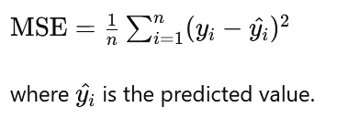

### Mathematical Representation

For a simple linear regression with one feature:

y=β0+β1X+ε

For multiple linear regression with multiple features:

y=β0+β1X1+β2X2+...+βnXn+ε

### Assumptions

1. **Linearity**: The relationship between the dependent and independent variables is linear.
2. **Independence**: Observations are independent.
3. **Homoscedasticity**: Constant variance of the errors.
4. **Normality**: Errors are normally distributed.

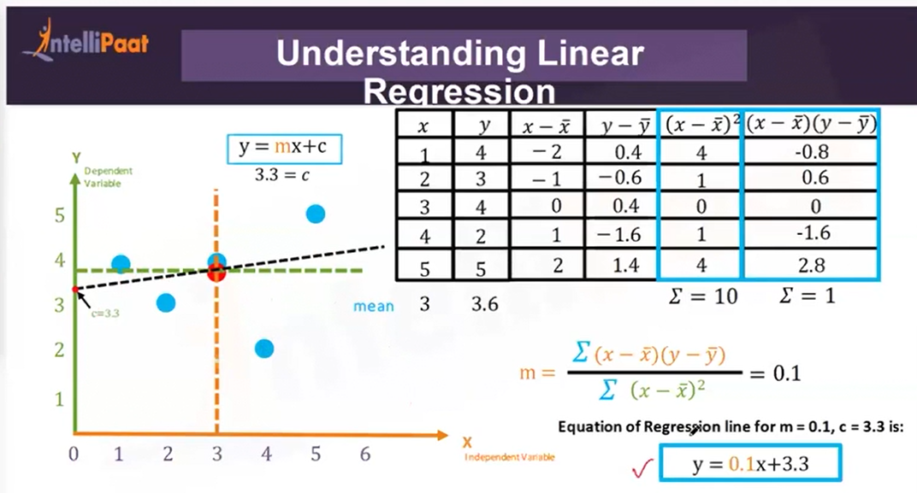

### Sum of Square Errors (SSEs)

In the context of linear regression, SSE stands for **Sum of Squared Errors**. It is a measure of the discrepancy between the data and the estimation model. Specifically, SSE is the sum of the squared differences between the observed values (the actual data points) and the values predicted by the model.

Mathematically, SSE is calculated as follows:

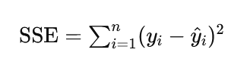

where:

* yi​ represents the actual value of the dependent variable for the i-th observation.
* y^​i​ represents the predicted value of the dependent variable for the i-th observation, obtained from the regression model.
* n is the total number of observations.

The lower the SSE, the better the model fits the data, as it indicates that the predicted values are close to the actual values. SSE is a crucial component in various metrics for evaluating model performance, such as the Mean Squared Error (MSE) and the Root Mean Squared Error (RMSE). It is also used in determining the coefficient of determination, R2, which measures the proportion of the variance in the dependent variable that is predictable from the independent variable(s).

### Mean Square Error (MSE)

It is a measure of the average squared differences between the observed actual outcomes and the outcomes predicted by the linear regression model. MSE is commonly used to evaluate the performance of a regression model and to compare the accuracy of different models.

Mathematically, MSE is calculated as follows:

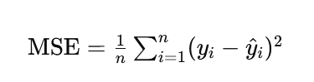

where:

* yi​ represents the actual value of the dependent variable for the i-th observation.
* y^​i​ represents the predicted value of the dependent variable for the i-th observation, obtained from the regression model.
* n is the total number of observations.

#### Why Use MSE?

* **Penalty for Large Errors**: By squaring the differences, MSE penalizes larger errors more heavily than smaller ones, which is useful for identifying models that might produce large outliers.
* **Differentiability**: The MSE function is differentiable, making it suitable for optimization techniques such as gradient descent used in training many types of regression models.

#### Interpretation of MSE

* **Lower MSE**: Indicates a better fit of the model to the data, as the average squared difference between the actual and predicted values is smaller.
* **Higher MSE**: Indicates a poorer fit, with larger discrepancies between actual and predicted values.

# 1st June

Have to go through with recording

# 2nd June

Have to go through with recording

# 8th June

This class is repetition of last classes as it requires more understanding on Linear Regression.

## Linear Regression

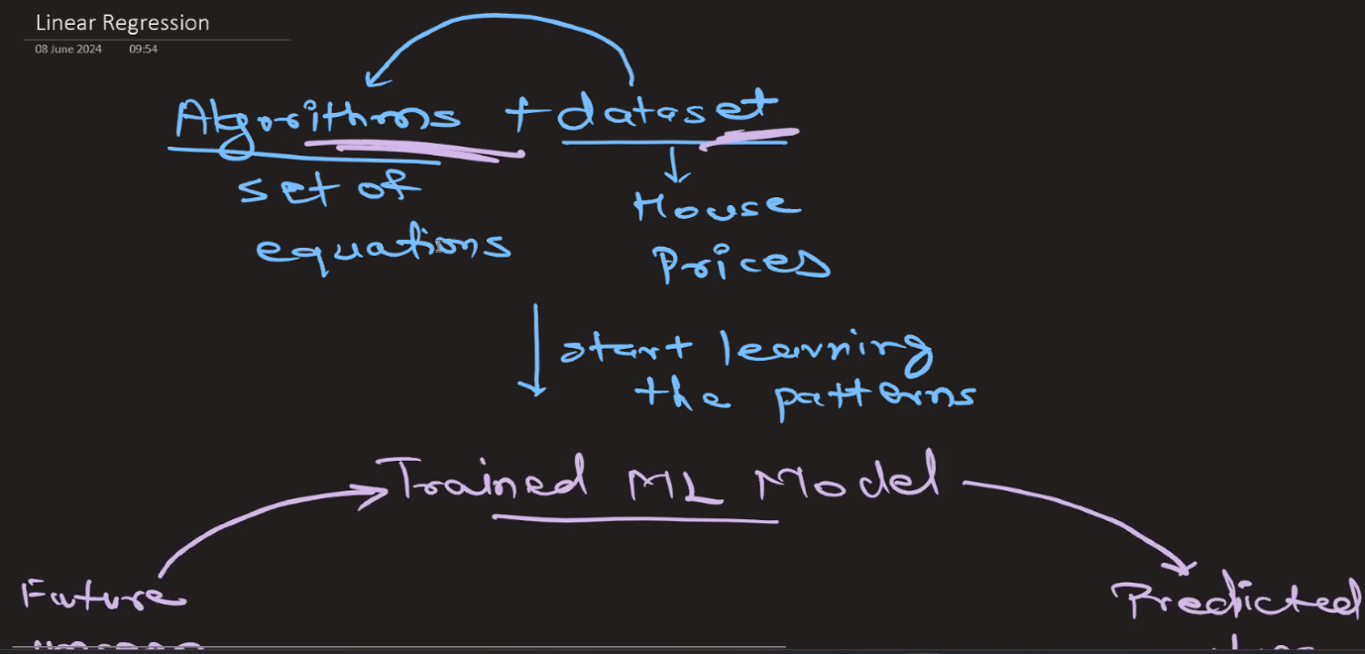

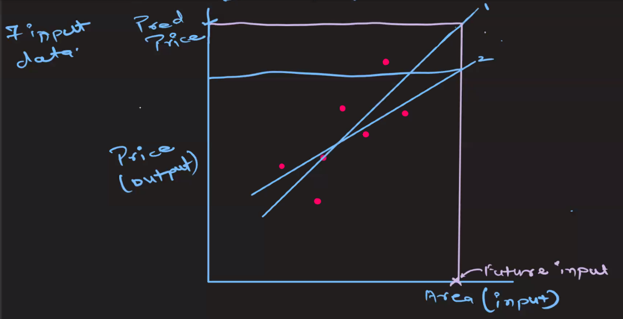

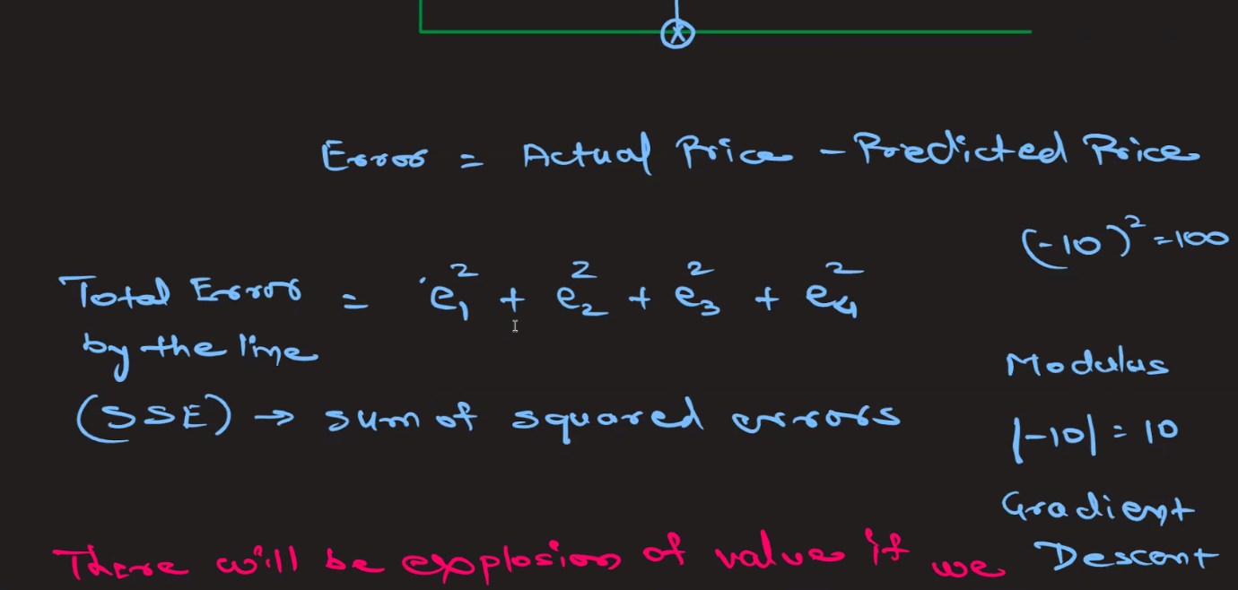

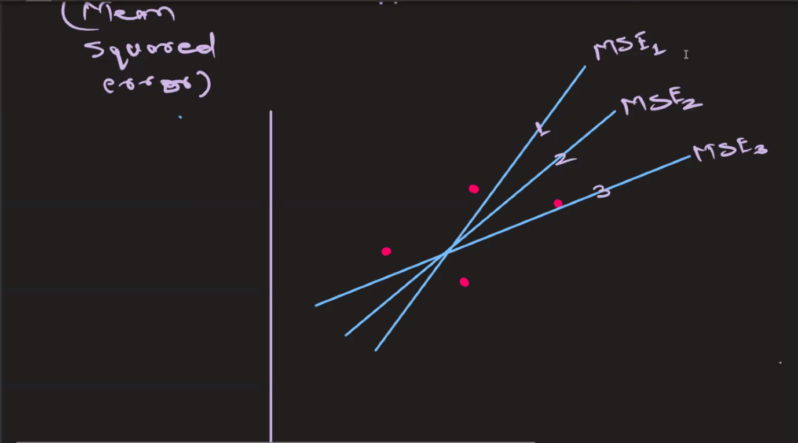

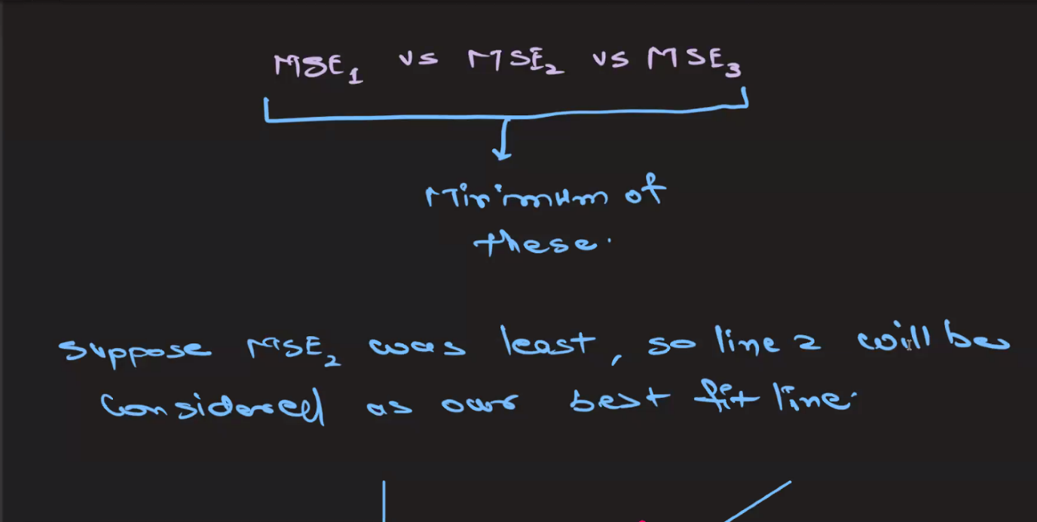

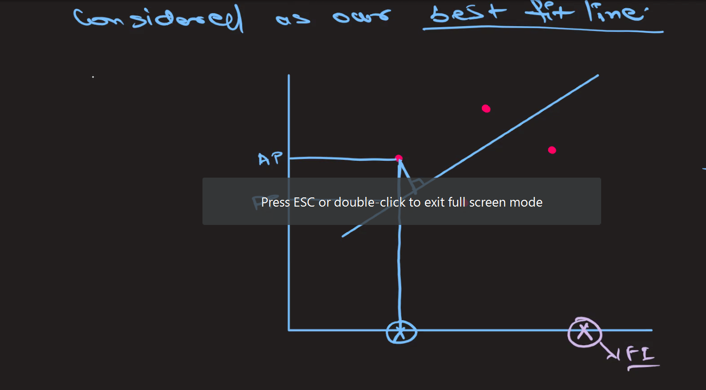

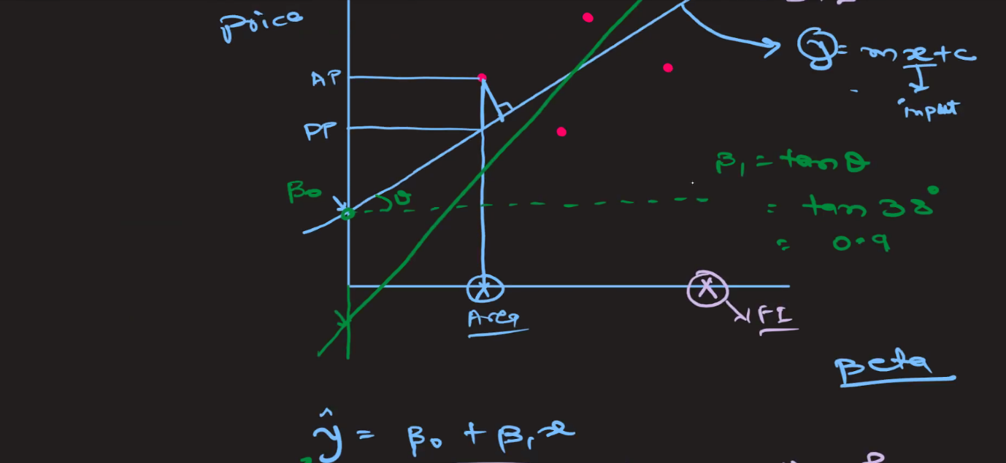

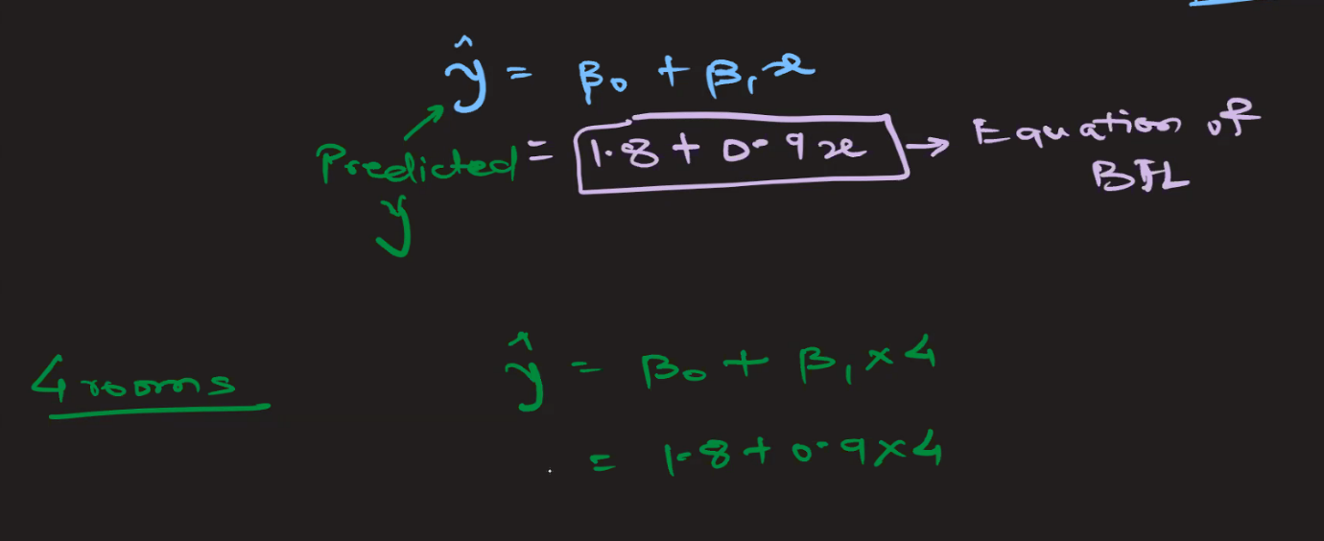

### **Homoscedasticity** and **Heteroscedasticity**

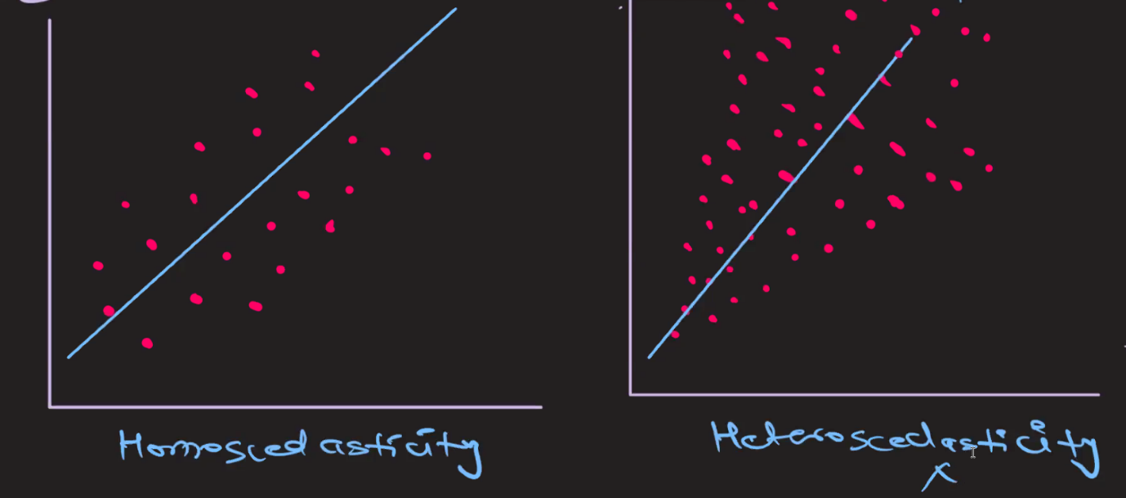

In the context of regression analysis, the terms **homoscedasticity** and **heteroscedasticity** refer to the nature of the variance of the errors (residuals) in a regression model.

#### Homoscedasticity

**Homoscedasticity** occurs when the variance of the errors is constant across all levels of the independent variables. In simpler terms, the spread or "scatter" of the residuals remains the same regardless of the value of the independent variable.

* **Graphical Representation**: When plotting the residuals against the predicted values or any independent variable, the residuals should form a horizontal band or scatter evenly around the horizontal axis. There should be no discernible pattern.
* **Implication for Regression**: Homoscedasticity is an assumption of ordinary least squares (OLS) regression. When this assumption holds, it means that the model's predictions are equally reliable across all values of the independent variables. It also ensures the validity of standard errors, confidence intervals, and hypothesis tests.

#### Heteroscedasticity

**Heteroscedasticity** occurs when the variance of the errors varies across different levels of the independent variables. In other words, the spread or "scatter" of the residuals changes (increases or decreases) with the value of the independent variable.

* **Graphical Representation**: When plotting the residuals against the predicted values or any independent variable, the residuals may fan out, form a cone shape, or show some other pattern indicating that the variance is not constant.
* **Implication for Regression**: Heteroscedasticity violates one of the key assumptions of OLS regression. This can lead to inefficient estimates of the coefficients and biased standard errors, making hypothesis tests and confidence intervals unreliable. It can also indicate that there are important variables missing from the model or that the functional form of the model is incorrect.

##### Diagnosing Heteroscedasticity

There are several methods to diagnose heteroscedasticity:

1. **Graphical Methods**:
   * **Residual Plot**: Plot the residuals versus the predicted values or versus an independent variable. Look for patterns that suggest changing variance.
   * **Scale-Location Plot**: Plot the square root of the absolute residuals versus the predicted values. A horizontal line suggests homoscedasticity, while a pattern indicates heteroscedasticity.
2. **Statistical Tests**:
   * **Breusch-Pagan Test**: Tests for linear forms of heteroscedasticity.
   * **White Test**: Tests for more general forms of heteroscedasticity.
   * **Goldfeld-Quandt Test**: Compares the variances of the residuals in two subsamples to test for heteroscedasticity.

##### Addressing Heteroscedasticity

If heteroscedasticity is detected, several strategies can be employed to address it:

1. **Transforming the Dependent Variable**: Applying a transformation such as the logarithm, square root, or Box-Cox transformation can stabilize the variance.
2. **Weighted Least Squares (WLS)**: Assigning different weights to observations based on the variance of their errors can account for heteroscedasticity.
3. **Robust Standard Errors**: Using heteroscedasticity-robust standard errors can make hypothesis tests more reliable without necessarily changing the coefficient estimates.

#### Example in Simple Linear Regression

##### Homoscedasticity Example:

* If you regress the height of a plant on the amount of sunlight it receives and the residuals have a constant spread irrespective of the amount of sunlight, your model demonstrates homoscedasticity.

##### Heteroscedasticity Example:

* If you regress the household expenditure on income and find that the residuals fan out as income increases, this suggests heteroscedasticity, indicating that the variability of household expenditure increases with income.

In summary, homoscedasticity and heteroscedasticity are concepts related to the variance of the residuals in a regression model. Homoscedasticity ensures that the regression model's predictions are equally reliable across all levels of the independent variables, while heteroscedasticity indicates a problem that can affect the efficiency and reliability of the model's estimates.

### Multicollinearity in Regression Analysis

**Multicollinearity** occurs in a regression analysis when two or more independent variables are highly correlated with each other. This means that one independent variable can be linearly predicted from the others with a substantial degree of accuracy.

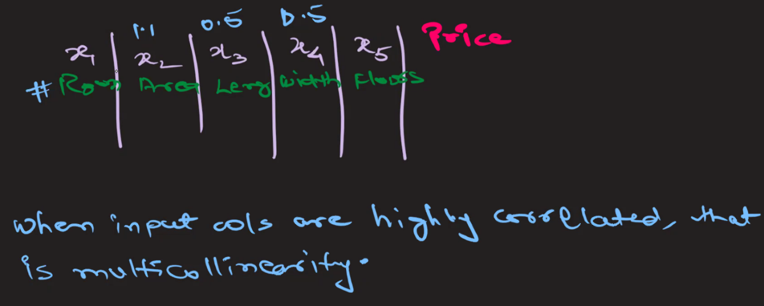

In above image, x3 and x4 can be removed as x2 itself represent those two columns.

#### Effects of Multicollinearity

Multicollinearity can lead to several problems in the interpretation of the regression model.

1. **Unstable Estimates**: The coefficients of the regression model can become very sensitive to changes in the model. Adding or removing a variable can cause large changes in the estimated coefficients.
2. **Inflated Standard Errors**: Multicollinearity increases the standard errors of the coefficients. This makes it harder to determine whether a coefficient is significantly different from zero.
3. **Reduced Predictive Power**: While the overall model might still have good predictive power, the reliability of individual coefficients diminishes.
4. **Difficulty in Assessing the Effect of Each Predictor**: It becomes challenging to ascertain the individual effect of each independent variable on the dependent variable because changes in one predictor are associated with changes in another.

#### Diagnosing Multicollinearity

There are several ways to diagnose multicollinearity:

* **Correlation Matrix**: A simple way to start is to look at the correlation matrix of the independent variables. High correlation coefficients (close to 1 or -1) between pairs of variables suggest multicollinearity.
* **Variance Inflation Factor (VIF)**: VIF quantifies how much the variance of a regression coefficient is inflated due to multicollinearity. A VIF value greater than 10 is often taken as an indication of significant multicollinearity, although some sources suggest a lower threshold

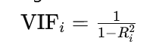

where Ri2​ is the coefficient of determination of the regression of the i-th independent variable on all other independent variables.

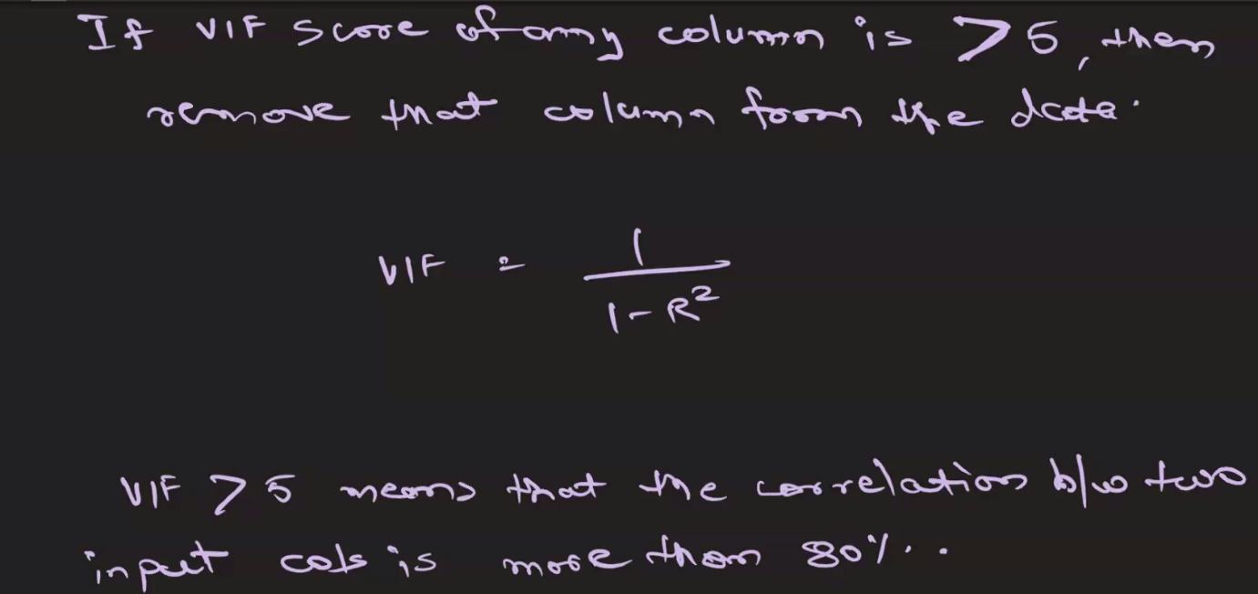

* **Tolerance**: Tolerance is the reciprocal of VIF. Low tolerance values (less than 0.1) indicate high multicollinearity.
  + Tolerancei=1−Ri2 ​

# 9th June

### Naive Model

In the context of evaluating predictive models using the R-squared (R2) score, a "naive model" refers to a simplistic baseline model that makes predictions without using any features or information from the dataset. Instead, it typically relies on basic summary statistics or simple algorithms to generate predictions.

Here's how a naive model relates to the R2 score:

1. **Simple Prediction Strategy**: A naive model often employs a straightforward prediction strategy, such as:
   * Using the mean, median, or mode of the target variable as the predicted value for all observations.
   * Using the last observed value as the predicted value for time-series data.
   * Assigning a constant value as the prediction.
2. **Lack of Information Utilization**: Since a naive model doesn't utilize any features or information from the dataset, its predictions are solely based on simplistic assumptions or generalizations. As a result, the predictions made by a naive model are typically very basic and may not capture the underlying patterns or relationships in the data.
3. **R2 Score Evaluation**: When evaluating a naive model using the R2 score, it serves as a baseline or reference point for comparison with more sophisticated models. The R2 score of a naive model can provide insights into the performance of more complex models relative to the simplest possible prediction strategy.
4. **Interpretation of R2 Score for Naive Model**: The R2 score of a naive model can help in understanding the degree to which more advanced models improve upon this basic prediction strategy. A higher R2 score for a more complex model indicates that it captures more variance in the target variable compared to the naive model. Conversely, a lower R2 score may suggest that the complex model doesn't offer significant improvements over the naive approach.
5. **Cautions**: It's essential to interpret the R2 score of a naive model within the context of the specific problem and dataset. While a low R2 score for a naive model indicates that the model doesn't capture much variance, achieving a higher R2 score with a more complex model doesn't necessarily guarantee its superiority without considering other factors such as model interpretability, generalization performance, and computational complexity.

In summary, a naive model provides a basic benchmark for evaluating the predictive performance of more sophisticated models, and the R2 score helps quantify the improvement achieved by these

### Adjusted R-squared

Adjusted R-squared is a modified version of the R-squared statistic that has been adjusted for the number of predictors in the model. It addresses one of the limitations of R-squared by penalizing excessive use of predictors that may not significantly improve the model's explanatory power.

Here's how it works:

1. **Adjustment for Complexity**: Adjusted R-squared takes into account the number of predictors in the model. As more predictors are added, R-squared tends to increase, even if those predictors don't add much explanatory power. Adjusted R-squared penalizes this increase in R-squared that might be due to chance or overfitting.
2. **Formula**: The formula for Adjusted R-squared is:

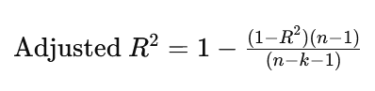

Where:

* R2R^2R2 is the R-squared value.
* nnn is the number of observations.
* kkk is the number of predictors (independent variables).

1. **Interpretation**: Like R-squared, Adjusted R-squared also ranges between 0 and 1. A higher Adjusted R-squared indicates a better fit of the model to the data. If the adjusted R-squared is close to 1, it means that a large proportion of the variability in the dependent variable is explained by the independent variables.
2. **Usefulness**: Adjusted R-squared is useful for comparing the goodness of fit of models with different numbers of predictors. It helps in selecting the most appropriate model among competing models by considering both the goodness of fit and model complexity.
3. **Limitation**: While Adjusted R-squared addresses the issue of model complexity, it still doesn't provide information about whether the model assumptions are met or whether the coefficients are biased.

In summary, Adjusted R-squared provides a more reliable measure of the goodness of fit, particularly when comparing models with different numbers of predictors.

## Logistic Regression

Logistic Regression is a statistical method used for binary classification tasks, where the dependent variable (or target variable) is categorical and has only two possible outcomes, typically labeled as 0 and 1. Despite its name, logistic regression is used for classification, not regression.

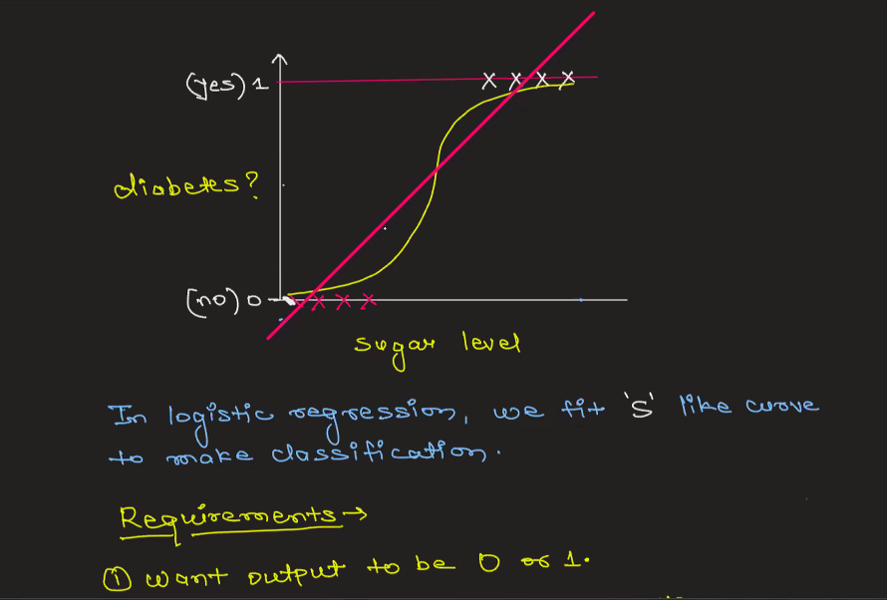

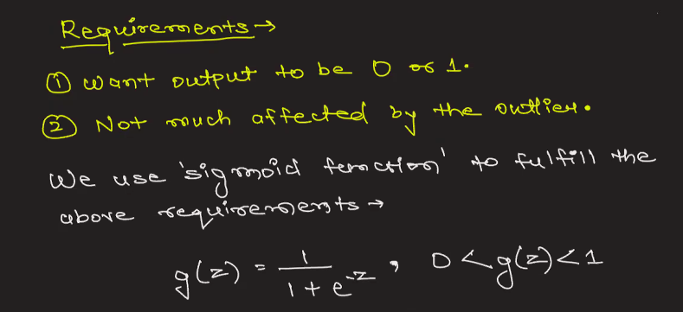

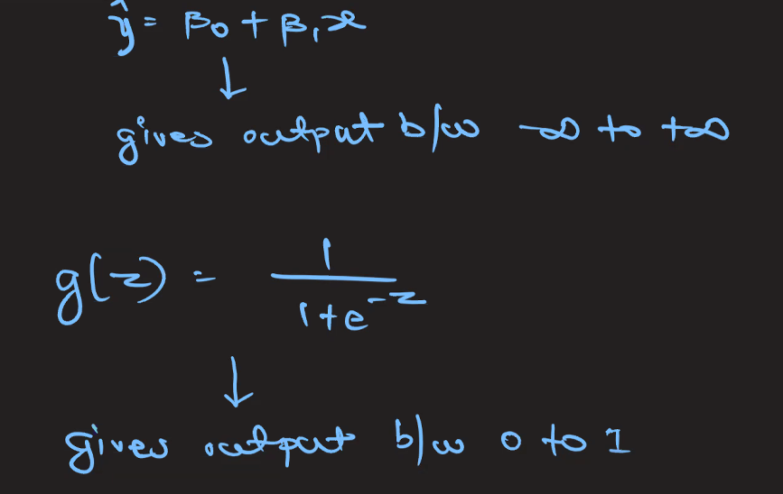

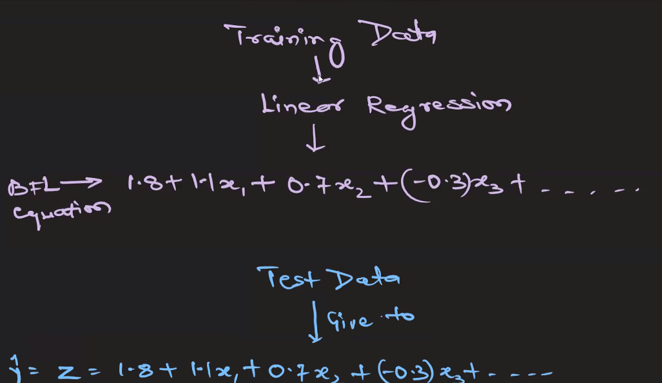

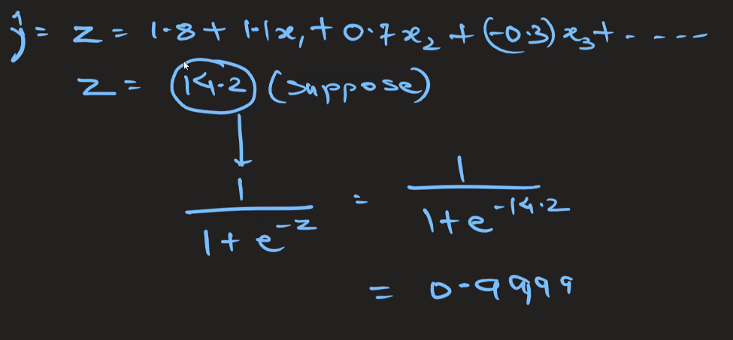

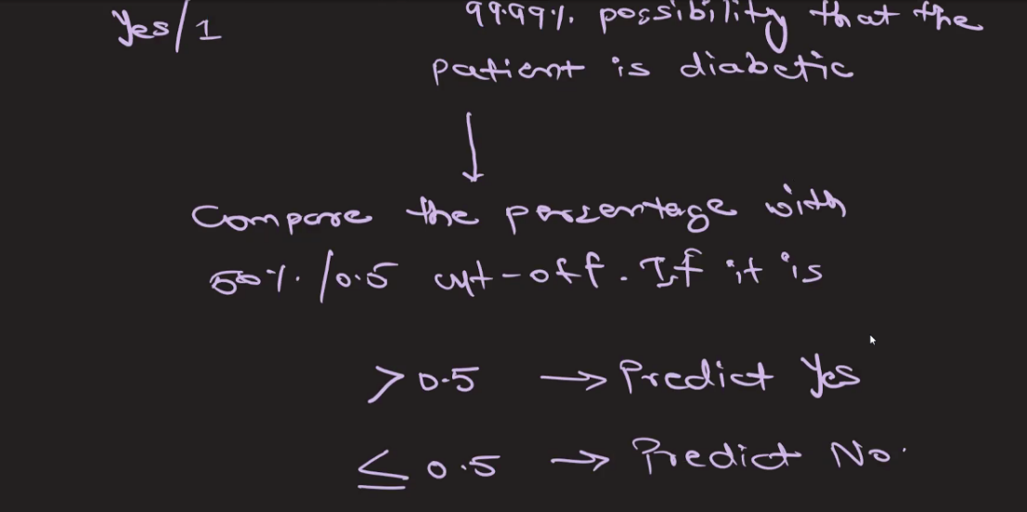

### Measure of Spread

In statistics, "spread" refers to the extent to which data values are dispersed or distributed across a dataset. It provides insights into the variability or dispersion of the data points around a central tendency measure, such as the mean or median. There are several measures of spread commonly used in statistics:

1. **Range**: The range is the simplest measure of spread and is calculated as the difference between the maximum and minimum values in the dataset. While it's easy to compute, it's sensitive to outliers and may not provide a robust measure of variability.
2. **Interquartile Range (IQR)**: The IQR is a robust measure of spread that is less affected by outliers compared to the range. It is calculated as the difference between the third quartile (Q3) and the first quartile (Q1) of the dataset. The IQR contains the middle 50% of the data.
3. **Variance**: Variance measures the average squared deviation of each data point from the mean of the dataset. It provides a measure of how much the data points are spread out around the mean. However, it is not in the same units as the original data, making it less interpretable.
4. **Standard Deviation**: The standard deviation is the square root of the variance and is expressed in the same units as the original data. It provides a measure of the average deviation of data points from the mean. Standard deviation is widely used due to its interpretability and ease of calculation.
5. **Mean Absolute Deviation (MAD)**: MAD measures the average absolute deviation of data points from the mean of the dataset. Unlike variance and standard deviation, MAD is less sensitive to extreme values and provides a robust measure of spread.
6. **Coefficient of Variation (CV)**: CV is the ratio of the standard deviation to the mean, expressed as a percentage. It provides a measure of relative variability, allowing comparison of variability between datasets with different units or scales.

These measures of spread are essential for understanding the distribution of data, identifying outliers, and making informed decisions in statistical analysis and data interpretation. The choice of measure depends on the characteristics of the dataset and the specific goals of the analysis.

# 15th June

### Startify attribute

The stratify attribute is used in the context of splitting data into training and testing sets to ensure that the distribution of classes in the target variable is preserved in both subsets. This is particularly useful in scenarios where you have an imbalanced dataset, meaning the number of instances in each class is not equal.

#### Importance of Stratification

In an imbalanced dataset, if you randomly split the data without stratification, you might end up with training and testing sets that do not accurately represent the overall distribution of classes. This can lead to biased model performance metrics, as the model might be trained on a skewed representation of the data and evaluated on another skewed representation.

#### How Stratification Works

Stratification ensures that the proportion of each class in the target variable is approximately the same in both the training and testing sets. For example, if your dataset has 70% instances of class 0 and 30% instances of class 1, stratified sampling will ensure that both the training and testing sets maintain this 70-30 ratio.

#### Usage Example in Python with train_test_split

In Python, you can use the stratify attribute in the train_test_split function from the sklearn.model_selection module to achieve stratified sampling.

Here's an example:

import numpy as np

from sklearn.model_selection import train_test_split

# Generate some sample data

np.random.seed(0)

X = np.random.rand(100, 2)

y = np.random.choice([0, 1], size=(100,), p=[0.7, 0.3]) # Imbalanced dataset: 70% of class 0, 30% of class 1

# Split the data into training and test sets with stratification

X_train, X_test, y_train, y_test = train_test_split(X, y, test_size=0.3, **stratify=y**, random_state=0)

# Check the distribution of classes in the original, training, and test sets

print('Original class distribution:', np.bincount(y) / len(y))

print('Training set class distribution:', np.bincount(y_train) / len(y_train))

print('Test set class distribution:', np.bincount(y_test) / len(y_test))

#### Output Explanation

The output of the above code will show that the class distribution in the original dataset is preserved in both the training and test sets:

Original class distribution: [0.7 0.3]

Training set class distribution: [0.7 0.3]

Test set class distribution: [0.7 0.3]

#### When to Use Stratification

* **Imbalanced Datasets**: When one class significantly outnumbers another.
* **Classification Problems**: Ensuring that both training and testing sets are representative of the overall class distribution is crucial for training robust classifiers.
* **Cross-Validation**: When performing cross-validation, stratified sampling ensures that each fold has a similar class distribution.

#### Summary

Stratification is a crucial technique to ensure that the model training and evaluation processes are not biased by an uneven distribution of classes in the target variable. It helps maintain the representativeness of the datasets and improves the reliability of model performance metrics.

### random_state attribute

The random_state parameter is used in various machine learning algorithms and functions, such as train_test_split, to ensure reproducibility of results. It controls the randomness involved in processes like data shuffling and splitting, random sampling, and initializing weights in machine learning models.

#### Why Use random_state?

1. **Reproducibility**: Setting a random_state ensures that the results are reproducible. This means that every time you run your code with the same random_state, you'll get the same results. This is crucial for debugging, comparing model performance, and sharing your work with others.
2. **Consistency**: It allows for consistent results across different runs, making it easier to track changes and understand the impact of modifications to the code or model.

#### How random_state Works

* **Integer**: When you pass an integer to random_state, it initializes the random number generator to a specific state. This ensures that the sequence of random numbers (and hence the results) is the same every time.
* **None**: If random_state is set to None, the random number generator is initialized based on the current system time. This results in different outcomes for each run.
* **Instance of numpy.random.RandomState**: You can also pass an instance of numpy.random.RandomState for more control over the random number generation.

### fit_transform vs transform

In the context of data preprocessing in machine learning, the methods fit_transform and transform are used for scaling, normalizing, or encoding data. These methods are often found in preprocessing classes in libraries such as scikit-learn. Understanding the difference between them is crucial for correctly applying transformations to your dataset.

#### fit_transform

The fit_transform method is a combination of two operations: fitting and transforming.

1. **Fit**: It calculates the necessary statistics (e.g., mean and standard deviation for scaling, or min and max for normalization) from the data provided. This step "learns" the parameters needed for the transformation.
2. **Transform**: It applies the transformation using the parameters learned during the fitting step.

#### When to Use fit_transform

* **Training Data**: You should use fit_transform on your training data. This ensures that the transformation is based on the training data only, which prevents data leakage from the test set.

#### transform

The transform method only applies the transformation using the parameters learned during the fit step. It does not calculate new parameters; it simply uses the existing ones.

#### When to Use transform

* **Test Data or New Data**: After fitting the transformer on the training data using fit_transform, you should use transform on the test data or any new data to ensure that it is transformed in the same way as the training data.

#### Summary

1. **fit_transform**:
   * Combines fitting and transforming.
   * Used on training data.
   * Learns parameters from the training data and then applies the transformation.
2. **transform**:
   * Only applies the transformation.
   * Used on test data or new data.
   * Uses the parameters learned from the training data.

## Decision Trees

Decision trees are a popular and versatile type of machine learning model used for both classification and regression tasks. They are intuitive to understand and interpret, and they can handle both numerical and categorical data. Here’s a detailed overview of decision trees:

### 1. **Concept and Structure**

A decision tree is a flowchart-like tree structure where:

* **Internal Nodes**: Represent tests on features (e.g., whether a feature value is greater than a threshold).
* **Branches**: Represent the outcome of the test.
* **Leaf Nodes**: Represent the final output (class label for classification, continuous value for regression).

### 2. **How Decision Trees Work**

1. **Splitting**: The tree splits the data at each node based on a feature that results in the best separation of the data points. The choice of the best feature and split can be based on various criteria:
   * **Classification Trees**: Use criteria like Gini impurity, information gain (entropy), or misclassification error.
   * **Regression Trees**: Use criteria like mean squared error (MSE) or mean absolute error (MAE).
2. **Stopping Criteria**: The tree continues to split until it reaches a stopping criterion, such as:
   * A maximum tree depth.
   * A minimum number of samples required to split a node.
   * A minimum number of samples required to be at a leaf node.
   * No further improvement in splitting criterion.
3. **Prediction**:
   * **Classification Trees**: Assign the most common class of the training samples in the leaf node.
   * **Regression Trees**: Assign the mean or median value of the training samples in the leaf node.

### 3. **Advantages and Disadvantages**

**Advantages**:

* **Easy to Understand and Interpret**: Trees can be visualized and are easy to explain to non-experts.
* **Non-linear Relationships**: Can capture non-linear relationships between features.
* **Feature Importance**: Can provide an estimate of the importance of different features in the prediction.

**Disadvantages**:

* **Overfitting**: Trees can become very complex and overfit the training data, especially if not pruned or regularized.
* **Instability**: Small changes in the data can result in completely different trees.
* **Bias**: Trees can be biased if some classes dominate.

### 4. **Pruning**

Pruning reduces the size of the tree by removing sections of the tree that provide little power in predicting target variables. It helps to avoid overfitting. There are two types of pruning:

* **Pre-pruning (Early Stopping)**: Stop growing the tree earlier based on predefined conditions.
* **Post-pruning**: Grow the full tree and then remove non-significant branches.

### 5. **Important Parameters**

* **Criterion**: The function to measure the quality of a split (e.g., "gini" for Gini impurity, "entropy" for information gain in classification; "mse" for mean squared error in regression).
* **Max Depth**: The maximum depth of the tree.
* **Min Samples Split**: The minimum number of samples required to split an internal node.
* **Min Samples Leaf**: The minimum number of samples required to be at a leaf node.
* **Max Features**: The maximum number of features considered for splitting a node.

### 6. **Ensemble Methods**

Decision trees are often used as the building blocks for more powerful ensemble methods:

* **Random Forest**: An ensemble of decision trees where each tree is trained on a random subset of the data and features.
* **Gradient Boosting Machines (GBM)**: Sequentially builds trees, each trying to correct the errors of the previous ones.

## Occam's Razor Principle

Occam's razor is a principle from philosophy and science that suggests when faced with competing hypotheses or explanations, the one that makes the fewest assumptions should be selected. In other words, the simplest explanation is usually the correct one.

### Origin and Explanation

Occam's razor is named after the English philosopher and theologian William of Ockham (1287–1347), who is credited with advocating this principle. The term "razor" refers to the "shaving away" of unnecessary assumptions to find the simplest path.

### Application in Science and Machine Learning

In science and machine learning, Occam's razor is used as a heuristic to guide the development of models and theories:

1. **Model Selection**: When comparing different models that explain the data equally well, the simpler model (with fewer parameters and assumptions) is generally preferred. This helps avoid overfitting, where a more complex model fits the training data very well but performs poorly on new, unseen data.
2. **Feature Selection**: In the context of machine learning, Occam's razor suggests selecting a model with fewer features if it achieves similar performance to a model with more features. This can lead to more interpretable and generalizable models.

### Examples

* **Linear Regression vs. Polynomial Regression**: For a given dataset, a simple linear regression model might be preferred over a higher-degree polynomial regression model if both have similar predictive performance on a validation set. The linear model is simpler and less likely to overfit.
* **Decision Trees**: When constructing decision trees, it's often beneficial to limit the depth of the tree. A simpler, shallower tree that generalizes well is preferred over a very deep tree that fits the training data perfectly but may overfit.

### Mathematical Formulation

While Occam's razor is more of a philosophical guideline, it can be formalized in various ways in machine learning, such as through regularization techniques that penalize model complexity:

* **L1 Regularization (Lasso)**: Encourages sparsity in the model parameters, effectively setting some coefficients to zero and thus simplifying the model.
* **L2 Regularization (Ridge)**: Penalizes large coefficients to prevent the model from becoming overly complex.

### Practical Considerations

Occam's razor should not be applied blindly. The simplest model is not always the best; sometimes, the complexity of the phenomenon being modeled justifies a more complex model. The key is to find a balance between simplicity and explanatory power, ensuring the model is as simple as possible without sacrificing accuracy and generalizability.

### Summary

Occam's razor is a valuable heuristic in the scientific method and machine learning, advocating for simplicity and the avoidance of unnecessary complexity. By adhering to this principle, researchers and practitioners can develop models that are not only easier to understand and interpret but also more likely to generalize well to new data.

# 16th June

### Overfitting vs Underfitting

#### Overfitting

**Definition:** Overfitting occurs when a model learns the training data too well, capturing noise and outliers along with the underlying pattern. This leads to a model that performs exceptionally well on the training data but poorly on new, unseen data.

**Causes:**

* **Complex Models:** Using models that are too complex relative to the amount of training data, such as deep neural networks with many layers or decision trees with many splits.
* **Too Many Features:** Including irrelevant or redundant features can lead to overfitting, as the model tries to account for these extra features in the training data.
* **Insufficient Training Data:** When the amount of training data is small, the model might not be able to generalize well.

**Symptoms:**

* **Low Training Error, High Validation/Test Error:** The model shows very low error on the training set but performs poorly on validation or test sets.
* **High Variance:** Model performance varies significantly across different training datasets.

**Solutions:**

* **Simpler Models:** Use simpler models that are less prone to capturing noise in the training data.
* **Regularization:** Techniques like L1 (Lasso) and L2 (Ridge) regularization add a penalty to the loss function to discourage overly complex models.
* **Cross-Validation:** Use cross-validation to ensure the model generalizes well to different subsets of the data.
* **More Training Data:** Increasing the amount of training data can help the model learn the underlying pattern without overfitting to noise.

#### Underfitting

**Definition:** Underfitting occurs when a model is too simple to capture the underlying pattern in the data. This leads to poor performance on both the training data and new, unseen data.

**Causes:**

* **Too Simple Models:** Using models that are too simple, such as linear regression for data that has a non-linear pattern.
* **Insufficient Features:** Not including enough features or using features that do not capture the underlying patterns in the data.
* **Too Much Regularization:** Excessive regularization can prevent the model from learning the underlying pattern in the data.

**Symptoms:**

* **High Training Error, High Validation/Test Error:** The model shows high error on both the training and validation/test sets.
* **High Bias:** The model makes strong assumptions about the data and cannot capture the underlying pattern.

**Solutions:**

* **More Complex Models:** Use more complex models that can capture the underlying patterns in the data.
* **Feature Engineering:** Add relevant features or transform existing features to better capture the underlying patterns.
* **Reduce Regularization:** If regularization is too high, decrease it to allow the model to learn more from the training data.

#### Balancing Overfitting and Underfitting

Achieving a balance between overfitting and underfitting is crucial for building effective machine learning models. Here are some strategies to find this balance:

* **Cross-Validation:** Use cross-validation techniques to tune hyperparameters and select models that perform well on unseen data.
* **Model Selection:** Start with simple models and gradually increase complexity, monitoring performance on validation data to avoid overfitting.
* **Regularization:** Apply regularization techniques judiciously to prevent overfitting while allowing the model to learn from the data.
* **Early Stopping:** In iterative learning algorithms like neural networks, use early stopping to halt training when performance on a validation set starts to degrade.

By understanding and addressing overfitting and underfitting, you can build models that generalize well and make accurate predictions on new data.

### Entropy

**Definition:** Entropy is a measure from information theory that quantifies the amount of disorder or randomness in a system. In the context of decision trees, it measures the impurity or disorder of a set of labels.

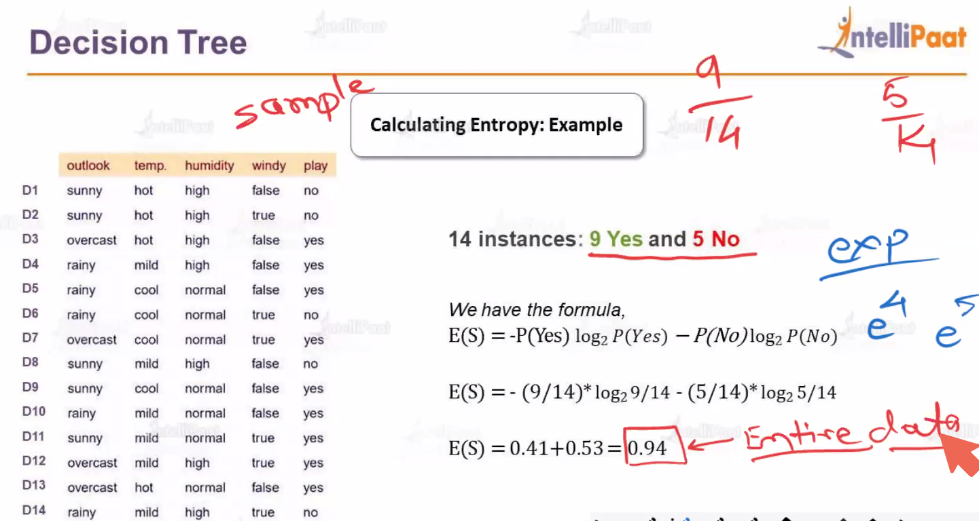

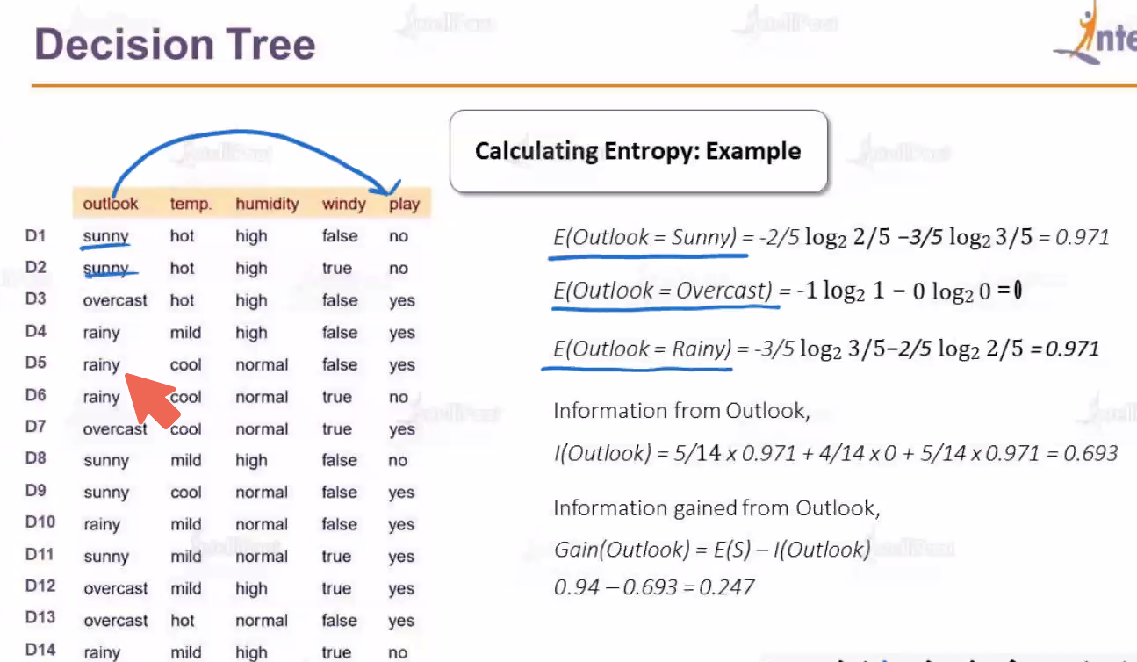

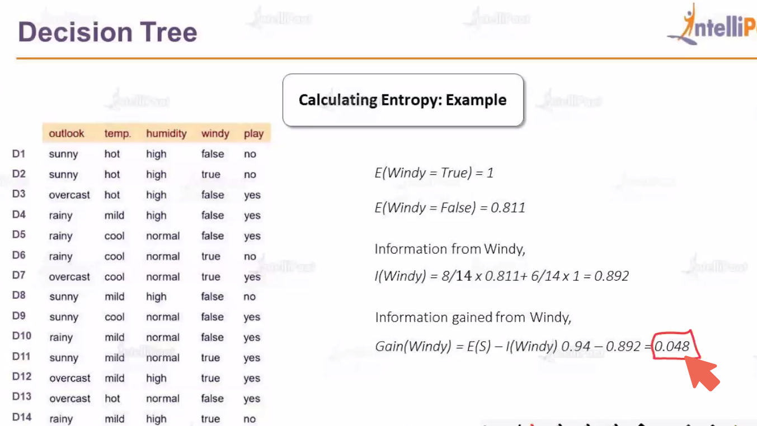

### Conclusion

Entropy is a fundamental concept in decision trees, used to measure the impurity of a node and to decide the best splits by maximizing information gain. By minimizing entropy at each split, decision trees create branches that lead to purer and more homogeneous subsets, improving the model's ability to classify new data.

## Random Forest

Random Forest is a versatile and powerful machine learning algorithm used for both classification and regression tasks. It operates by constructing multiple decision trees during training and outputs the mode of the classes (classification) or mean prediction (regression) of the individual trees.

### Key Concepts

1. **Ensemble Learning**: Random Forest is an ensemble learning method, meaning it combines the predictions of several base estimators (decision trees) to improve robustness and accuracy.
2. **Decision Trees**: A decision tree is a simple model that splits the data into branches to make predictions. Each split is based on a feature that maximizes some criterion (e.g., Gini impurity or entropy for classification).
3. **Bagging (Bootstrap Aggregating)**: Random Forest uses bagging, where each tree is trained on a random subset of the data with replacement. This means some data points are repeated, and some are left out, ensuring diversity among the trees.
4. **Random Feature Selection**: At each split in the decision tree, Random Forest considers a random subset of features. This decorrelates the trees, further improving the ensemble's performance.

### How Random Forest Works

1. **Training Phase**:
   * **Bootstrap Sampling**: Randomly sample n instances from the dataset with replacement to create a bootstrap sample.
   * **Tree Construction**: For each bootstrap sample, grow a decision tree. At each node, instead of considering all features for the best split, consider a random subset of features.
   * **Tree Growth**: Continue splitting nodes until a stopping criterion is met (e.g., maximum depth, minimum number of samples per leaf).
2. **Prediction Phase**:
   * **Classification**: Each tree in the forest votes for a class, and the final prediction is the majority vote.
   * **Regression**: Each tree predicts a value, and the final prediction is the average of all the tree predictions.

### Advantages

* **Improved Accuracy**: By combining multiple trees, Random Forest often achieves higher accuracy than individual decision trees.
* **Robustness**: It is less prone to overfitting compared to a single decision tree because it averages multiple trees.
* **Feature Importance**: It can provide estimates of feature importance, helping to understand the contribution of each feature to the model's predictions.
* **Versatility**: Works well for both classification and regression problems and can handle large datasets with higher dimensionality.

### Disadvantages

* **Complexity**: A Random Forest model with many trees can be computationally expensive and slow to train and predict.
* **Interpretability**: While individual decision trees are easy to interpret, the ensemble of trees in a Random Forest is more complex and less interpretable.

### Hyperparameters

1. **n_estimators**: The number of trees in the forest. More trees generally improve performance but increase computational cost.
2. **max_features**: The number of features to consider when looking for the best split. Options include:
   * 'auto' (default for classification, sqrt(features))
   * 'sqrt' (square root of the number of features)
   * 'log2' (logarithm base 2 of the number of features)
   * An integer value
   * A float representing a fraction of the total number of features
3. **max_depth**: The maximum depth of the trees. Limiting the depth can prevent overfitting.
4. **min_samples_split**: The minimum number of samples required to split an internal node.
5. **min_samples_leaf**: The minimum number of samples required to be at a leaf node.
6. **bootstrap**: Whether to use bootstrap samples when building trees. Default is True.

### Example in Python (scikit-learn)

import numpy as np

from sklearn.datasets import load_iris

from sklearn.model_selection import train_test_split

from sklearn.ensemble import RandomForestClassifier

from sklearn.metrics import accuracy_score

# Load dataset

data = load_iris()

X = data.data

y = data.target

# Split dataset into training and test sets

X_train, X_test, y_train, y_test = train_test_split(X, y, test_size=0.2, random_state=42)

# Initialize the model

rf = RandomForestClassifier(n_estimators=100, random_state=42)

# Fit the model

rf.fit(X_train, y_train)

# Make predictions

y_pred = rf.predict(X_test)

# Evaluate the model

accuracy = accuracy_score(y_test, y_pred)

print("Test Set Accuracy:", accuracy)

# Feature importance

importances = rf.feature_importances_

for feature, importance in zip(data.feature_names, importances):

print(f"Feature: {feature}, Importance: {importance}")

### Conclusion

Random Forest is a powerful and flexible machine learning algorithm that leverages the strengths of multiple decision trees to improve predictive performance and robustness. Its ability to handle large datasets, reduce overfitting, and provide feature importance makes it a popular choice for a wide range of applications. However, it requires careful tuning of hyperparameters and can be computationally intensive.

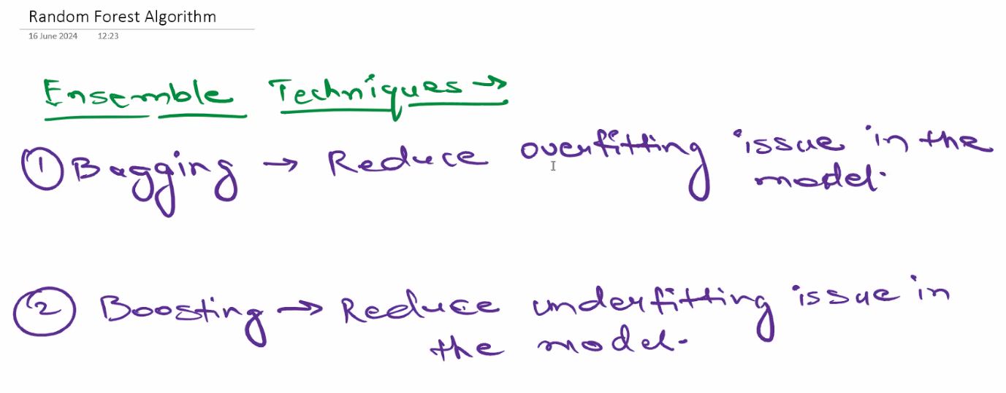

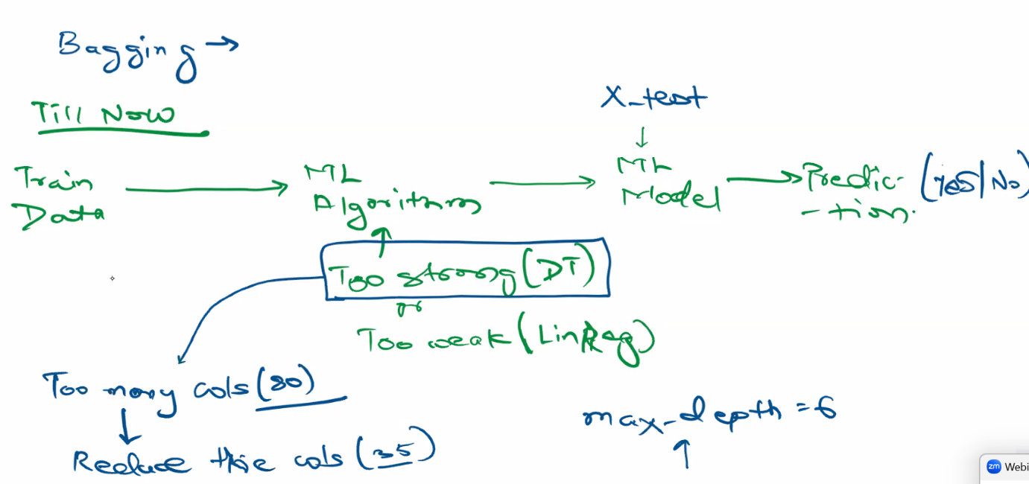

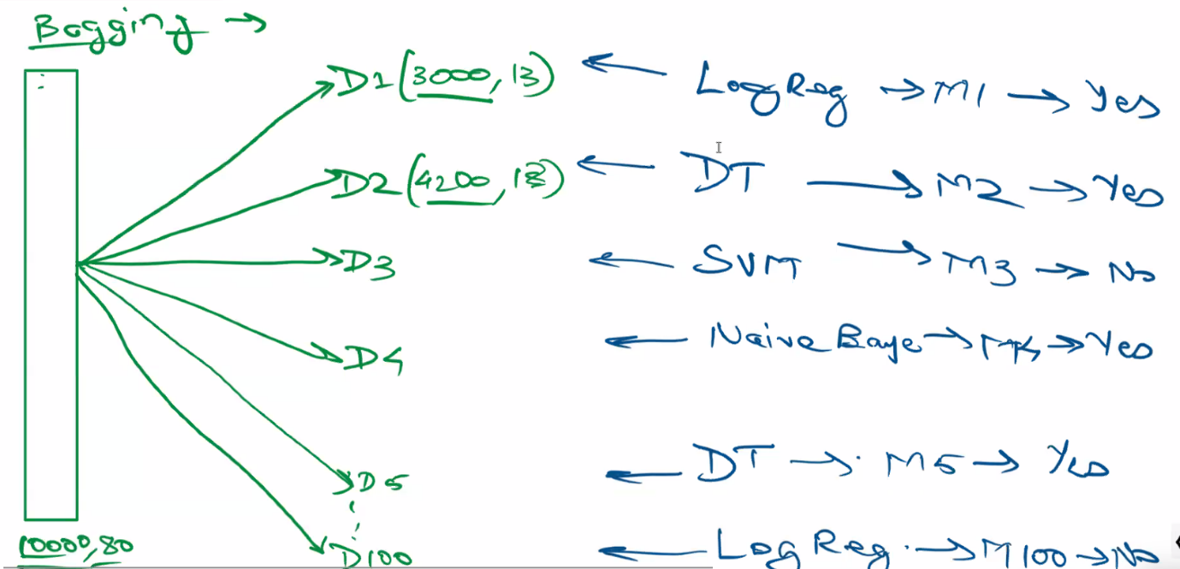

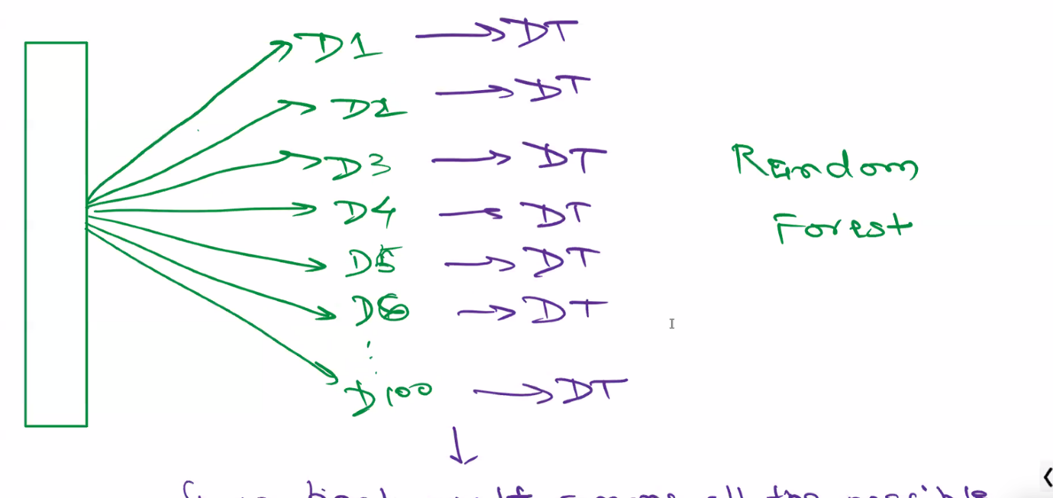 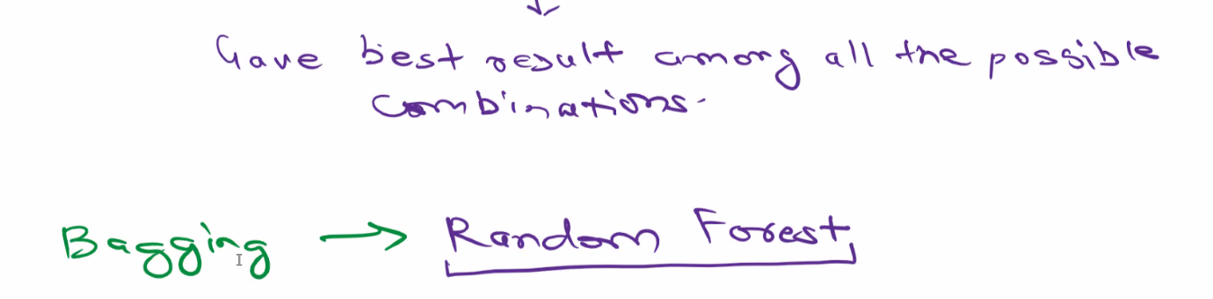

# 22nd June

## Bias vs variance Error

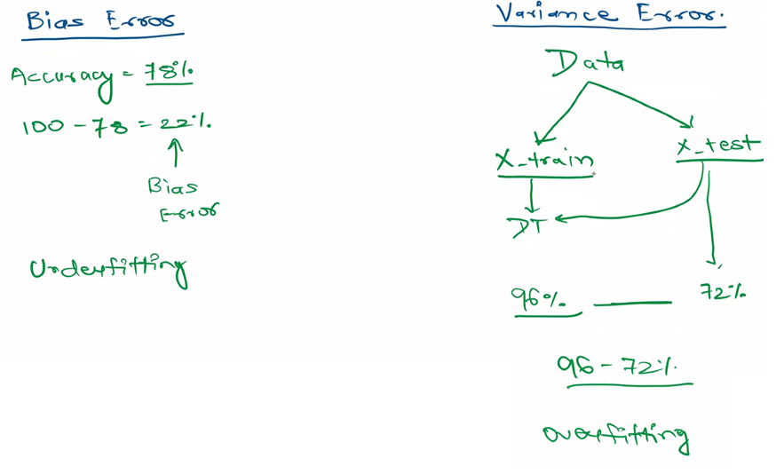

Bias error and variance error are two components of the total prediction error in machine learning models. Understanding the trade-off between bias and variance is crucial for developing models that generalize well to new data. Here's a detailed explanation of each:

### Bias Error

**Bias** refers to the error introduced by approximating a real-world problem, which may be complex, by a much simpler model. In other words, bias is the error due to overly simplistic assumptions in the learning algorithm.

* **High Bias**: A model with high bias pays very little attention to the training data and oversimplifies the model. It leads to high training error and high error on the validation/test set. Such models are said to underfit the data. Examples include linear regression for a non-linear problem or a very shallow decision tree.
* **Low Bias**: A model with low bias closely follows the training data and captures the underlying patterns. However, this does not necessarily mean it will generalize well, as it could be overfitting the training data.

### Variance Error

**Variance** refers to the model's sensitivity to small fluctuations in the training data. A model with high variance pays a lot of attention to the training data, including noise, and as a result, it can model the random noise in the training data rather than the intended outputs.

* **High Variance**: A model with high variance can perform very well on the training data but poorly on unseen data because it captures the noise in the training data. This leads to overfitting. Examples include a very deep decision tree or a highly complex neural network with many parameters.
* **Low Variance**: A model with low variance is less sensitive to the specific training data and captures the underlying distribution well, leading to better generalization to new data.

### Techniques to Address Bias and Variance

* **For High Bias (Underfitting)**:
  + Use more complex models
  + Increase the number of features
  + Reduce regularization
* **For High Variance (Overfitting)**:
  + Use simpler models
  + Reduce the number of features
  + Increase regularization
  + Use more training data
  + Implement cross-validation techniques

In summary, balancing bias and variance is crucial for building models that generalize well. This often involves iterative experimentation and validation to find the optimal model complexity for a given problem.

## Synthetic Data

Synthetic data plays a significant role in machine learning (ML) for various reasons. Here are some key aspects:

### 1. **What is Synthetic Data?**

Synthetic data is artificially generated data that mimics the statistical properties of real-world data. It can be created using various techniques, including simulations, generative models, and rule-based methods.

### 2. **Uses of Synthetic Data in ML**

* **Training Data:** Used when real data is scarce, expensive to collect, or subject to privacy constraints.
* **Testing and Validation:** Helps in testing models more rigorously by providing diverse and challenging scenarios.
* **Data Augmentation:** Enhances the size and diversity of the training set, improving model robustness and performance.
* **Anonymization:** Maintains privacy by using synthetic data instead of real, sensitive data.
* **Scenario Testing:** Allows testing models in controlled conditions and edge cases.

### 3. **Generating Synthetic Data**

* **Random Sampling:** Simple statistical methods to generate data points from a known distribution.
* **Simulations:** Creating data based on complex models or simulations of real-world processes.
* **Generative Adversarial Networks (GANs):** Neural networks designed to generate realistic data by learning the distribution of the training data.
* **Variational Autoencoders (VAEs):** Another type of neural network used for generating data by learning latent representations.
* **Rule-Based Systems:** Generating data based on predefined rules or heuristics.

### 4. **Advantages of Synthetic Data**

* **Cost-Effective:** Reduces the need for expensive data collection and labeling processes.
* **Scalability:** Easy to generate large volumes of data.
* **Privacy:** Avoids the use of sensitive or personal data, thus mitigating privacy concerns.
* **Customization:** Allows creating specific scenarios and edge cases that may not be present in real data.

### 5. **Challenges and Considerations**

* **Quality:** Ensuring that synthetic data accurately represents real-world data distributions.
* **Bias:** Avoiding the introduction of biases present in the synthetic data.
* **Complexity:** Generating high-quality synthetic data can be computationally intensive and require sophisticated models.
* **Validation:** Ensuring the synthetic data leads to models that generalize well to real-world data.

### Summary

Synthetic data is a valuable resource in machine learning, providing numerous benefits such as cost reduction, scalability, and privacy. However, its effective use requires careful consideration of data quality, bias, and validation to ensure robust and generalizable ML models.

## Oversampling and Undersampling

Oversampling and undersampling are techniques used to address class imbalance in datasets, particularly in the context of classification problems. Here's a detailed explanation of both techniques, their purposes, and their respective advantages and disadvantages:

### Oversampling

**Oversampling** involves increasing the number of instances in the minority class to match the number of instances in the majority class. This can be done through various methods:

#### Methods of Oversampling

1. **Random Oversampling**: Simply duplicates random instances from the minority class until the classes are balanced.
2. **SMOTE (Synthetic Minority Over-sampling Technique)**: Generates synthetic samples by interpolating between existing minority class instances. SMOTE creates new instances that are combinations of nearby minority instances.
3. **ADASYN (Adaptive Synthetic Sampling)**: Similar to SMOTE but focuses on generating more synthetic data in regions where the minority class is sparsely represented.

#### Advantages of Oversampling

* **Balances the Dataset**: Helps create a balanced dataset, making it easier for machine learning models to learn from the minority class.
* **Improves Model Performance**: Can improve the performance of classifiers by providing more examples of the minority class, leading to better generalization.
* **Preserves All Majority Class Data**: No information is lost from the majority class, as new instances are added to balance the dataset.

#### Disadvantages of Oversampling

* **Overfitting Risk**: Random oversampling can lead to overfitting, especially if duplicates of minority instances are created.
* **Increased Computational Load**: Adding more instances to the dataset increases the computational cost of training the model.

### Undersampling

**Undersampling** involves reducing the number of instances in the majority class to balance the dataset with the minority class. This can also be done through various methods:

#### Methods of Undersampling

1. **Random Undersampling**: Randomly removes instances from the majority class until the classes are balanced.
2. **Tomek Links**: Removes instances from the majority class that are close to minority class instances, aiming to make the classes more separable.
3. **Cluster-Based Undersampling**: Uses clustering techniques to identify and remove redundant or similar instances from the majority class.

#### Advantages of Undersampling

* **Balances the Dataset**: Helps create a balanced dataset, making it easier for machine learning models to learn from both classes.
* **Reduces Training Time**: By reducing the size of the dataset, it can decrease the computational load and training time for the model.
* **Prevents Overfitting**: Less risk of overfitting compared to oversampling, especially with sophisticated undersampling techniques.

#### Disadvantages of Undersampling

* **Information Loss**: Potentially valuable information from the majority class can be lost, which may lead to a less robust model.
* **Lower Performance**: If not done carefully, undersampling can lead to a model that does not generalize well, especially if important majority class instances are removed.

### Choosing Between Oversampling and Undersampling

The choice between oversampling and undersampling depends on several factors, including the dataset, the machine learning algorithm being used, and the specific problem being addressed.

1. **Dataset Size**: If the dataset is small, undersampling might remove too much information, making oversampling a better choice. Conversely, if the dataset is very large, undersampling can reduce computational costs.
2. **Model Type**: Some models are more sensitive to class imbalance than others. For instance, tree-based models like Random Forests can handle imbalanced data better than models like logistic regression.
3. **Computational Resources**: Oversampling increases the size of the dataset, which can be computationally expensive. Undersampling reduces the size of the dataset, saving computational resources.

### Practical Tips

* **Combination Approaches**: Sometimes, a combination of both techniques works best. For example, using SMOTE to generate synthetic minority instances and then applying undersampling to reduce the majority class.
* **Cross-Validation**: Always use cross-validation to evaluate the impact of oversampling and undersampling techniques on model performance.
* **Feature Engineering**: Sometimes, improving feature engineering can help mitigate class imbalance without the need for extensive sampling techniques.

In summary, both oversampling and undersampling are valuable techniques for handling class imbalance, each with its own strengths and limitations. The choice between them should be guided by the specific context of the problem, dataset characteristics, and computational constraints.

## Confusion Matrix

A **confusion matrix** is a table used to evaluate the performance of a classification model. It provides a comprehensive summary of how well the classification model is performing by showing the correct and incorrect predictions broken down by each class. This matrix helps in understanding the types of errors being made by the model.

### Structure of a Confusion Matrix

A confusion matrix for a binary classification problem typically has the following structure:

|  | **Predicted Positive** | **Predicted Negative** |
| --- | --- | --- |
| **Actual Positive** | True Positive (TP) | False Negative (FN) |
| **Actual Negative** | False Positive (FP) | True Negative (TN) |

For multiclass classification, the matrix is extended accordingly, with rows and columns representing the actual and predicted classes respectively.

### Key Terms

1. **True Positive (TP)**: The model correctly predicts the positive class.
2. **True Negative (TN)**: The model correctly predicts the negative class.
3. **False Positive (FP)**: The model incorrectly predicts the positive class (Type I error).
4. **False Negative (FN)**: The model incorrectly predicts the negative class (Type II error).

### Metrics Derived from the Confusion Matrix

From the confusion matrix, several performance metrics can be calculated to evaluate the effectiveness of the classification model:

#### **Accuracy**

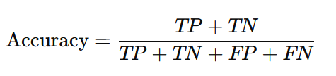

Accuracy measures the proportion of correct predictions among the total number of cases processed.

#### **Precision** (Positive Predictive Value)

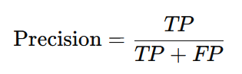

Precision measures the proportion of true positive predictions among all positive predictions made by the model.

#### **Recall** (Sensitivity or True Positive Rate)

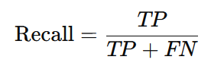

Recall measures the proportion of actual positives that were correctly identified by the model.

#### F1 Score

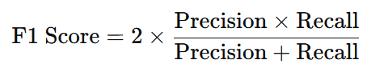

The F1 Score is the harmonic mean of precision and recall, providing a single metric that balances both concerns.

#### **Specificity** (True Negative Rate)

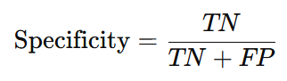

Specificity measures the proportion of actual negatives that were correctly identified by the model.

#### False Positive Rate (FPR)

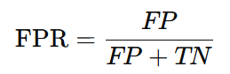

FPR indicates the proportion of actual negatives that were incorrectly classified as positive.

#### False Negative Rate (FNR)

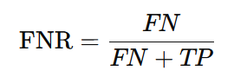

FNR indicates the proportion of actual positives that were incorrectly classified as negative.

### Example

Consider a binary classification model predicting whether emails are spam or not. Here's an example of a confusion matrix for this model:

|  | **Predicted Spam** | **Predicted Not Spam** |
| --- | --- | --- |
| **Actual Spam** | 80 | 20 |
| **Actual Not Spam** | 10 | 90 |

From this matrix, we can derive:

* **True Positives (TP)** = 80 (correctly predicted spam emails)
* **True Negatives (TN)** = 90 (correctly predicted non-spam emails)
* **False Positives (FP)** = 10 (non-spam emails incorrectly predicted as spam)
* **False Negatives (FN)** = 20 (spam emails incorrectly predicted as non-spam)

Using these values, we can calculate the performance metrics like accuracy, precision, recall, and F1 score.

### Importance of the Confusion Matrix

The confusion matrix is a crucial tool for:

* Identifying types of errors made by the classification model.
* Understanding the performance of a model beyond simple accuracy, especially in cases of imbalanced datasets.
* Guiding improvements to the model by highlighting areas where it may be underperforming.

In summary, the confusion matrix provides a detailed breakdown of model performance, offering insights into both correct and incorrect predictions, which is essential for thorough model evaluation and improvement.

## Accuracy Score vs ROC_AUC_Score

**Accuracy Score** and **ROC AUC Score** are two different metrics used to evaluate the performance of classification models, and they provide different insights into the model's effectiveness. Here's a detailed comparison of both:

### Accuracy Score

**Accuracy** measures the proportion of correct predictions (both true positives and true negatives) out of the total number of predictions. It is a straightforward metric that gives an overall sense of how often the classifier is correct.



#### Advantages

* **Simplicity**: Easy to understand and compute.
* **General Performance**: Provides a quick overview of the model's general performance.

#### Disadvantages

* **Class Imbalance**: Can be misleading in cases of class imbalance. For example, in a dataset with 95% negative instances and 5% positive instances, a model that always predicts the negative class will have high accuracy but is not useful.

### ROC AUC Score

**ROC AUC Score** (Receiver Operating Characteristic - Area Under the Curve) is a performance measurement for classification problems at various threshold settings. ROC is a probability curve, and AUC represents the degree or measure of separability. It tells how much the model is capable of distinguishing between classes.

#### Components

1. **True Positive Rate (TPR)** or **Recall**:



1. **False Positive Rate (FPR)**:



The ROC curve plots TPR against FPR at various threshold settings. The AUC is the area under the ROC curve and provides a single value summary of the model's performance across all thresholds.

#### Advantages

* **Threshold Independence**: Measures the model's performance across all classification thresholds.
* **Class Imbalance**: More informative in the presence of class imbalance, as it considers both TPR and FPR.

#### Disadvantages

* **Interpretability**: Less intuitive than accuracy for those unfamiliar with ROC curves and AUC.
* **Computation**: Requires computation of the model’s performance at various thresholds, which can be more complex.

### When to Use Each Metric

* **Accuracy Score**: Use this when the classes are balanced and you need a simple measure of overall performance.
* **ROC AUC Score**: Use this when you have imbalanced classes or need to evaluate the model’s performance across different classification thresholds.

### Summary

* **Accuracy Score** is simple and gives a general performance measure but can be misleading with imbalanced data.
* **ROC AUC Score** provides a comprehensive evaluation by considering all threshold settings, making it more robust in the presence of class imbalance.

In summary, the choice between accuracy and ROC AUC depends on the specific context and nature of the classification problem you are dealing with.

## Naive Bayes algorithm

Use case: This algorithm is used to detect the spam messages.

# 23rd June

## CountVectorizer

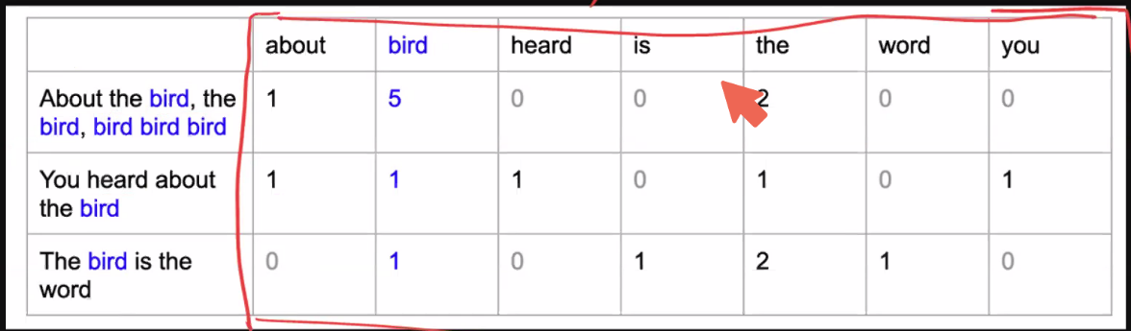

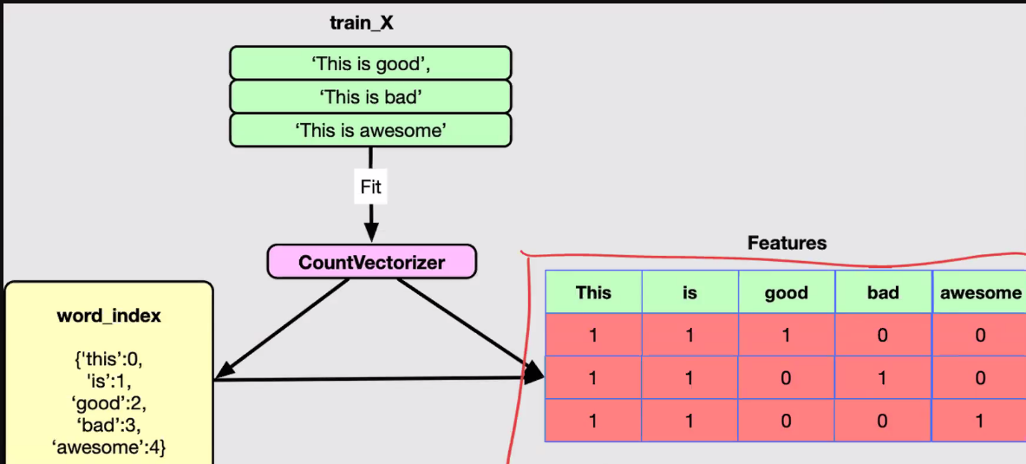

CountVectorizer is a common technique used in Natural Language Processing (NLP) and Machine Learning to convert a collection of text documents into a matrix of token counts. This transformation is essential for turning text data into numerical data that can be used by machine learning algorithms.

## K-Means algorithm

The K-Means algorithm is a popular and widely used clustering technique in machine learning. It aims to partition a set of data points into kkk clusters, where each data point belongs to the cluster with the nearest mean (centroid). This results in a partitioning of the data space into Voronoi cells.

### How K-Means Algorithm Works

The K-Means algorithm follows these steps:

1. **Initialization**: Choose kkk initial centroids randomly or using some heuristic.
2. **Assignment**: Assign each data point to the nearest centroid, forming kkk clusters.
3. **Update**: Calculate the new centroids as the mean of all the data points assigned to each cluster.
4. **Repeat**: Repeat the assignment and update steps until the centroids do not change significantly or a maximum number of iterations is reached.

### Detailed Steps

1. **Initialization**: Randomly initialize kkk centroids.
2. **Assignment Step**:
   * For each data point xix_ixi​, compute the distance to each centroid.
   * Assign xix_ixi​ to the cluster with the nearest centroid.
3. **Update Step**:
   * Calculate the new centroid of each cluster by taking the mean of all points assigned to that cluster
4. **Convergence**: Repeat the assignment and update steps until the centroids stabilize (do not change significantly) or a predetermined number of iterations is reached.

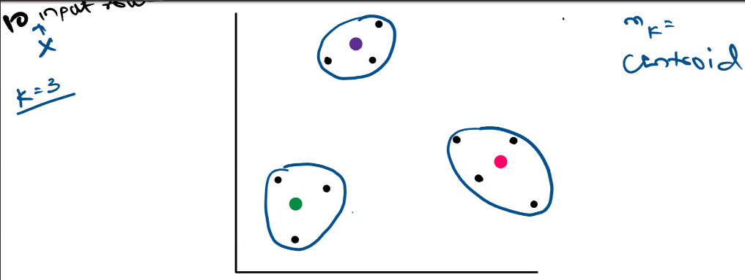

### Choosing the Number of Clusters (k)

Choosing the right number of clusters k is crucial for the performance of the K-Means algorithm. Common methods for determining k include:

#### **Elbow Method**

* **This is the widely used method.**
* Plot the **sum of squared distances** from each point to its assigned centroid (within-cluster sum of squares) for different values of k. The "elbow point," where the rate of decrease sharply slows, suggests a good value for k.

##### How the Elbow Method Works

1. **Fit the K-Means algorithm**: Run the K-Means algorithm for different values of kkk (e.g., from 1 to 10).
2. **Calculate the Within-Cluster Sum of Squares (WCSS)**: For each kkk, compute the sum of squared distances between data points and their respective cluster centroids. This is also known as inertia.
3. **Plot WCSS vs. kkk**: Create a plot with the number of clusters kkk on the x-axis and the WCSS on the y-axis.

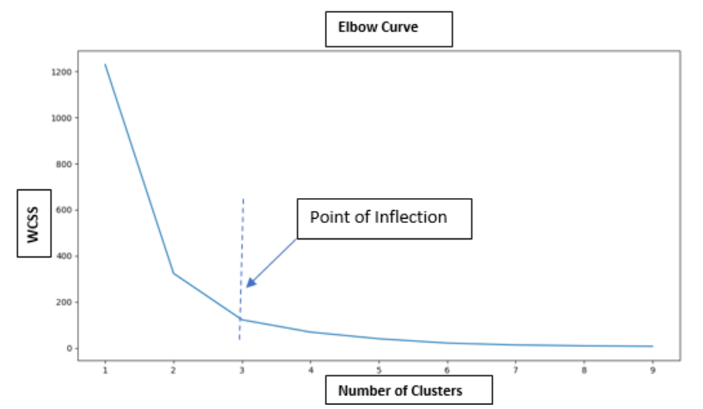

1. **Identify the "elbow" point**:
   * Look for the point on the plot where the WCSS starts to decrease at a slower rate. This point resembles an "elbow" and indicates the optimal number of clusters.
   * In above graph, we can consider 3 as elbow point
   * In Below graph, we can consider 7 as elbow point

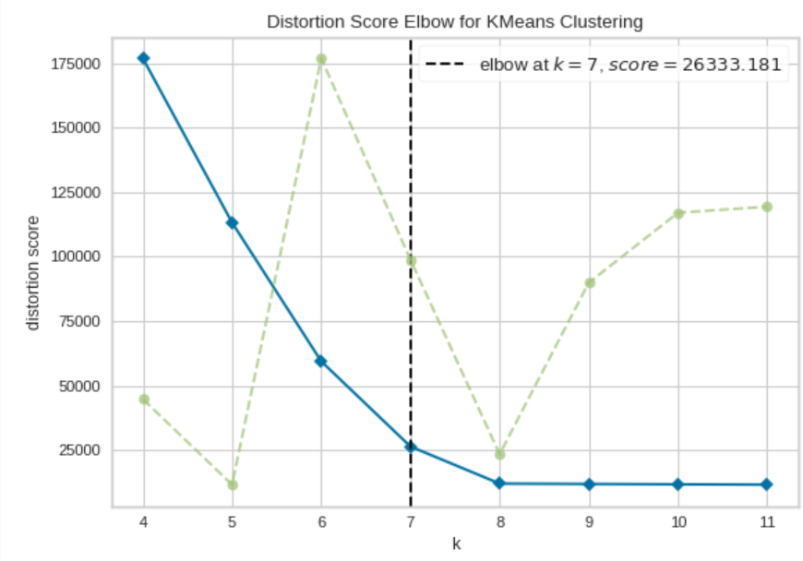

#### **Silhouette Score**

* Measures the quality of the clustering by calculating the average silhouette coefficient for each sample, which considers both the cohesion within clusters and the separation between clusters.

### Advantages and Disadvantages

#### Advantages:

* Simple and easy to implement.
* Computationally efficient for small to medium-sized datasets.
* Works well with spherical (convex) cluster shapes.

#### Disadvantages:

* Requires specifying the number of clusters kkk in advance.
* Sensitive to the initial placement of centroids (may converge to local minima).
* Assumes clusters are spherical and equally sized, which may not always be the case.
* Not suitable for identifying non-convex clusters.

### Conclusion

The K-Means algorithm is a powerful tool for clustering data into distinct groups. Its simplicity and efficiency make it a popular choice for many clustering tasks. However, care must be taken in choosing the appropriate number of clusters and interpreting the results, as well as in cases where the data may not meet the algorithm's assumptions.

## K-Means++

K-Means++ is an enhanced version of the standard K-Means clustering algorithm. The main improvement in K-Means++ is the way it initializes the cluster centroids, which helps to avoid poor initializations that can lead to suboptimal clustering results and slower convergence.

### How K-Means++ Works

K-Means++ improves the initialization of the centroids by using a probabilistic method that spreads out the initial cluster centers. Here are the steps of the K-Means++ initialization:

1. **Random Initialization**: Choose the first centroid randomly from the data points.
2. **Distance Calculation**: Compute the distance D(x)D(x)D(x) from each data point xxx to the nearest centroid that has already been chosen.
3. **Probabilistic Selection**: Select the next centroid from the data points with a probability proportional to D(x)2D(x)^2D(x)2. This means that points further away from the already chosen centroids have a higher probability of being selected as the next centroid.
4. **Repeat**: Repeat steps 2 and 3 until kkk centroids have been chosen.

### Benefits of K-Means++

1. **Better Initial Centroids**: The probabilistic selection ensures that the initial centroids are spread out, leading to better clustering results.
2. **Improved Convergence**: The initialization reduces the likelihood of poor clusters and helps the algorithm converge more quickly.
3. **Reduced Sensitivity**: It reduces the sensitivity to the initial placement of centroids, which is a common issue in the standard K-Means algorithm.

### Conclusion

K-Means++ is a significant improvement over the standard K-Means algorithm, mainly because of its superior method for initializing centroids. By choosing initial centroids that are spread out, K-Means++ leads to more accurate and faster convergence of the clustering process, making it a preferred choice in many practical applications of clustering.

# 29th June

### K-Means Algorithm Applications

Here is the list of applications of the K-Means algorithm:

1. Customer Segmentation
2. Image Segmentation
3. Document Clustering
4. Anomaly Detection
5. Biological Data Analysis
6. Market Basket Analysis
7. Social Network Analysis
8. Recommendation Systems
9. Climate and Weather Analysis
10. Healthcare
11. Finance
12. Urban Planning
13. Sports Analytics

### K-Means Clustering Drawbacks

Here are the drawbacks of the K-Means algorithm:

1. Choosing the Number of Clusters (K)
2. Sensitivity to Initialization
3. Assumption of Spherical Clusters
4. Sensitivity to Outliers
5. Scalability Issues
6. Cluster Assumption (Equal Variance)
7. Interpretability Challenges
8. Data Preprocessing Requirements (Feature Scaling)
9. Cluster Size Imbalance
10. Non-deterministic Results
11. Computational Complexity

#### 1. **Choosing the Number of Clusters (K)**

* **Predefined K**: The number of clusters KKK must be specified in advance, which is not always intuitive or easy to determine.
* **Trial and Error**: Determining the optimal KKK often involves running the algorithm multiple times with different KKK values and using methods like the elbow method or silhouette score.

#### 2. **Sensitivity to Initialization**

* **Local Minima**: K-Means can converge to different solutions depending on the initial positions of the centroids. Poor initialization can lead to suboptimal clustering.
* **K-Means++**: Although K-Means++ improves the initialization process, it does not completely eliminate the sensitivity issue.

#### 3. **Assumption of Spherical Clusters**

* **Shape Limitation**: K-Means assumes that clusters are spherical and equally sized. It does not perform well with clusters of arbitrary shapes, varying sizes, or densities.
* **Distance Metric**: The algorithm uses the Euclidean distance metric, which may not be appropriate for all types of data, especially if the data is not isotropic.

#### 4. **Sensitivity to Outliers**

* **Outliers and Noise**: K-Means is highly sensitive to outliers and noise. Outliers can distort the cluster centroids significantly.
* **Preprocessing**: Preprocessing steps like removing outliers or using robust clustering methods can help mitigate this issue.

#### 5. **Scalability**

* **Large Datasets**: Although K-Means is relatively efficient, it may struggle with very large datasets or high-dimensional data without optimization techniques.

#### 6. **Cluster Assumption**

* **Equal Variance**: K-Means assumes that all clusters have the same variance, which may not be the case in real-world data.
* **Non-convex Clusters**: K-Means is not suitable for detecting non-convex clusters. For example, it would struggle with clusters in the shape of moons or spirals.

#### 7. **Interpretability**

* **Cluster Interpretation**: While K-Means provides cluster assignments, interpreting the clusters and understanding what each cluster represents can be challenging.

#### 8. **Data Preprocessing Requirements**

* **Feature Scaling**: The performance of K-Means is affected by the scale of the features. Features should be normalized or standardized to ensure that no single feature dominates the distance computation.

#### 9. **Cluster Size Imbalance**

* **Uneven Cluster Sizes**: K-Means tends to produce clusters of similar sizes, which can be problematic if the actual clusters vary significantly in size.

#### 10. **Non-deterministic Results**

* **Random Initialization**: Due to its reliance on random initialization, K-Means can produce different results on different runs. Running the algorithm multiple times and averaging results or using consensus clustering can help achieve more stable results.

#### 11. **Computational Complexity**

* **Complexity**: The time complexity of K-Means is O(n⋅K⋅d⋅t)O(n \cdot K \cdot d \cdot t)O(n⋅K⋅d⋅t), where nnn is the number of data points, ddd is the dimensionality of the data, and ttt is the number of iterations. This can be computationally intensive for large datasets or high-dimensional data.

Despite these drawbacks, K-Means remains a valuable and widely used clustering algorithm. Its simplicity and efficiency make it suitable for many applications, especially when the limitations are understood and appropriately addressed.

## Hierarchical Clustering

Hierarchical clustering is a clustering algorithm that builds a hierarchy of clusters. It is often represented in a tree structure called a dendrogram. The two main types of hierarchical clustering are:

1. **Agglomerative (Bottom-Up)**
2. **Divisive (Top-Down)**

### Agglomerative Hierarchical Clustering

This is the most common type of hierarchical clustering, where each data point starts as its own cluster, and pairs of clusters are merged as one moves up the hierarchy.

#### Steps:

1. **Start with each data point as a single cluster.**
2. **Compute the distance (or similarity) matrix for all clusters.**
3. **Merge the two closest clusters.**
4. **Update the distance matrix to reflect the merge.**
5. **Repeat steps 3 and 4 until only one cluster remains or a stopping criterion is met.**

### Divisive Hierarchical Clustering

This method starts with all data points in one cluster and splits them recursively.

#### Steps:

1. **Start with all data points in one cluster.**
2. **Select the cluster to split.**
3. **Perform the split (often using a flat clustering algorithm like K-Means).**
4. **Repeat steps 2 and 3 until each data point is its own cluster or a stopping criterion is met.**

### Proximity Matrix

A proximity matrix, also known as a distance matrix, is a square matrix used to represent the pairwise distances or similarities between a set of data points. In the context of clustering, a proximity matrix helps to quantify how close or similar the data points are to each other.

#### Construction of a Proximity Matrix

**Ex:**

|  |  |  |  |  |  |
| --- | --- | --- | --- | --- | --- |
|  | 2 | 6 | 9 | 11 | 3 |
| 2 | 0 | 4 | 7 | 9 | **1** |
| 6 | 4 | 0 | 3 | 5 | 3 |
| 9 | 7 | 3 | 0 | 2 | 6 |
| 11 | 9 | 5 | 2 | 0 | 8 |
| 3 | **1** | 3 | 6 | 8 | 0 |

The minimum path distance is between the nodes 2 and the 3 and the distance between them is: 1. Hence make them as Cluster.

In below table while making the (2, 3) clustering, followed below steps:

* Get the distance between 2,6 which is 4
* Get the distance between 3,6 which is 3
* Consider maximum value for (2,3) to 6 nodes
* Follow similarly for nodes 9 and 11 also.

|  |  |  |  |  |
| --- | --- | --- | --- | --- |
|  | 2,3 | 6 | 9 | 11 |
| 2,3 | 0 | 4 | 7 | 9 |
| 6 | 4 | 0 | 3 | 5 |
| 9 | 7 | 3 | 0 | 2 |
| 11 | 9 | 5 | 2 | 0 |

The minimum path distance is between the nodes 9 and the 11 and the distance between them is: 2. Hence make them as Cluster.

|  |  |  |  |
| --- | --- | --- | --- |
|  | 2,3 | 6 | 9,11 |
| 2,3 | 0 | 4 | 9 |
| 6 | 4 | 0 | 5 |
| 9,11 | 9 | 5 | 0 |

4 is the minimum path distance is between the nodes (2,3) and the 6. Hence make them as Cluster.

|  |  |  |
| --- | --- | --- |
|  | (2,3), 6 | 9,11 |
| (2,3), 6 | 0 | 9 |
| 9,11 | 9 | 0 |

### Dendrogram

A dendrogram is a tree-like diagram that records the sequences of merges or splits. The height of the branches represents the distance or dissimilarity at which clusters are merged or split.

Below is the Dendogram for the above data points

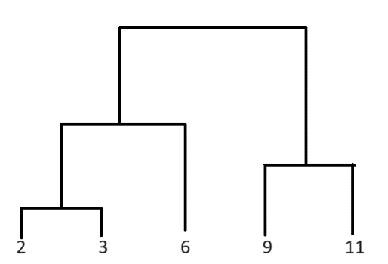

### Advantages

* **No Need to Specify the Number of Clusters**: The dendrogram can be cut at any level to produce the desired number of clusters.
* **Hierarchy of Clusters**: Provides a multilevel hierarchy, which can be useful for understanding the structure of the data.

### Disadvantages

* **Computational Complexity**: Generally, hierarchical clustering has a higher computational cost compared to K-Means, especially for large datasets.
* **Sensitivity to Noise and Outliers**: Can be sensitive to noise and outliers, which can affect the merging or splitting process.
* **Irreversible Merges**: In agglomerative clustering, once two clusters are merged, they cannot be split again. This can lead to suboptimal clustering if early merges are incorrect.

### Applications

* **Bioinformatics**: Gene expression data analysis, protein interaction analysis.
* **Text Mining**: Document clustering, topic modeling.
* **Market Research**: Customer segmentation, market basket analysis.
* **Image Analysis**: Image segmentation, pattern recognition.
* **Social Network Analysis**: Community detection, influencer identification.

# 30th June

### Linkage

The proximity between clusters is defined by a linkage criterion, which specifies the distance between sets of observations. Common linkage criteria include:

* **Single linkage (minimum linkage)**: the distance between the closest points of the clusters.
* **Complete linkage (maximum linkage)**: the distance between the farthest points of the clusters.
* **Average linkage**: the average distance between points in the clusters.
* **Centroid linkage**: the distance between the centroids of the clusters.
* **Ward's linkage**: minimizes the total within-cluster variance (also known as the error sum of squares, ESS).

### Metric

default=”euclidean”

The metric parameter specifies the distance metric used to compute the linkage. This distance metric is used to determine the proximity between clusters at each step of the clustering process.

Note:

* If linkage is “ward”, only “euclidean” is accepted.

Here are some commonly used distance metrics that can be specified using the metric parameter:

1. **Euclidean**: The standard straight-line distance between two points in Euclidean space.
2. **Manhattan** (or Cityblock): The sum of the absolute differences of their coordinates.
3. **Cosine**: Measures the cosine of the angle between two vectors.
4. **L1**: Another term for the Manhattan distance.
5. **L2**: Another term for the Euclidean distance.
6. **Precomputed**: Use a precomputed distance matrix.

## Association Rule Mining

Association rule mining is a technique used in data mining and machine learning to discover interesting relationships, patterns, or associations among a set of items in large datasets. It is commonly used in market basket analysis to find associations between items purchased together by customers.

### Key Concepts

1. **Itemset**: A collection of one or more items.
2. **Support**: The frequency or proportion of transactions in the dataset that contain a particular itemset. It indicates **how often an itemset appears** in the dataset.

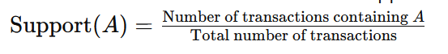

1. **Confidence**: The likelihood that a particular rule is correct. It is defined as the proportion of transactions that contain itemset AAA which also contain itemset BBB.

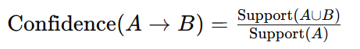

1. **Lift**: The ratio of the observed support to that expected if AAA and BBB were independent. It measures how much more likely BBB is to be purchased when AAA is purchased.

**Lift value will be:**

* + 1. **> 1, means very strongly associated between the products**
    2. **= 1, means association is by chance.**
    3. **<1, means those two items will never purchased together.**

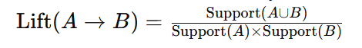

### Example

Suppose we have a dataset of transactions with the following items:

1. Bread
2. Milk
3. Butter
4. Eggs

An example rule might be: Bread→Butter\text{Bread} \rightarrow \text{Butter}Bread→Butter This means that if a customer buys bread, they are likely to also buy butter.

### Process of Association Rule Mining

1. **Frequent Itemset Generation**: Identify all itemsets that meet a minimum support threshold.
2. **Rule Generation**: From the frequent itemsets, generate all rules that meet a minimum confidence threshold.

### Algorithms

* **Apriori Algorithm**: One of the earliest and most widely used algorithms for **mining frequent itemsets** and generating association rules. It uses a bottom-up approach, where frequent subsets are extended one item at a time.
* **FP-Growth (Frequent Pattern Growth)**: An efficient algorithm that uses a divide-and-conquer strategy and a data structure called the FP-tree to mine frequent itemsets without candidate generation.

# 6th July

## Dimensionality Reduction

To mitigate overfitting or overloading in a Decision Tree, we use the max_depth parameter. However, using max_depth can result in the loss of some columns while calculating the accuracy score, potentially losing important data. To address this, we can use Dimensionality Reduction techniques, which can be applied in two ways:

1. PCA – Principal Component Analysis
2. LDA – Linear Discriminant Analysis

## Principal Component Analysis

Principal Component Analysis (PCA) is a statistical technique used in machine learning and data analysis **to reduce the dimensionality of a dataset** while preserving as much variability as possible. It transforms the data into a new coordinate system where the greatest variances are projected onto the first coordinates (principal components).

### Key Concepts

1. **Dimensionality Reduction**: PCA reduces the number of dimensions (features) in a dataset while retaining the essential information. This makes it easier to visualize and analyze the data.
2. **Principal Components**: New variables created by PCA, which are linear combinations of the original variables. The first principal component captures the maximum variance in the data, the second captures the second most variance, and so on.
3. **Variance**: PCA aims to maximize the variance captured by the principal components. The **more variance a principal component** captures, the more information it retains from the original dataset.
4. **Orthogonality**: Principal components are orthogonal (uncorrelated) to each other, ensuring that each component captures unique information.

### Steps in PCA

1. **Standardize the Data**: Ensure the data is centered (mean of zero) and scaled (standard deviation of one) if the features have different units or variances.
2. **Compute the Covariance Matrix**: Calculate the covariance matrix to understand the relationships between different features.
3. **Compute the Eigenvalues and Eigenvectors**: Calculate the eigenvalues and eigenvectors of the covariance matrix. Eigenvectors represent the directions of maximum variance (principal components), and eigenvalues represent the magnitude of variance in those directions.
4. **Sort and Select Principal Components**: Sort the eigenvalues in descending order and select the top k eigenvectors corresponding to the k largest eigenvalues to form a new feature space.
5. **Transform the Data**: Project the original data onto the new feature space formed by the top k eigenvectors.

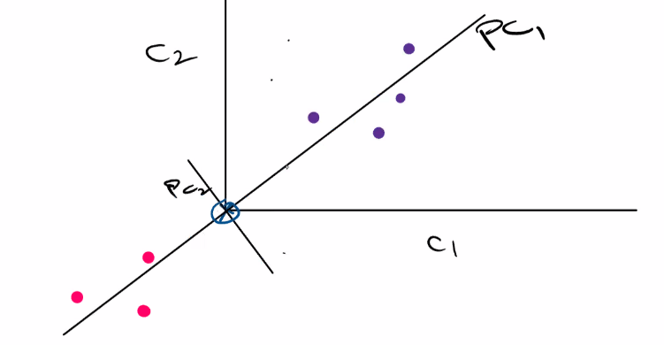

### Applications of PCA

1. **Data Visualization**: Reducing high-dimensional data to 2 or 3 dimensions for visualization.
2. **Noise Reduction**: Removing noise from data by keeping only the components that capture significant variance.
3. **Feature Extraction**: Creating new features (principal components) that summarize the original features.
4. **Data Compression**: Reducing the size of data while retaining important information.
5. **Preprocessing for Other Algorithms**: Simplifying the data for use in other machine learning algorithms, which might perform better with fewer, uncorrelated features.

### Advantages and Disadvantages

**Advantages:**

* Reduces the complexity of data and helps in better visualization.
* Removes multicollinearity by transforming correlated features into uncorrelated principal components.
* Improves the performance of machine learning models by eliminating noise and redundant features.

**Disadvantages:**

* PCA is a linear method and may not capture complex nonlinear relationships.
* The principal components may be difficult to interpret in terms of the original features.
* PCA assumes that the directions with the largest variances are the most important, which may not always be the case.

PCA is a powerful technique for dimensionality reduction, feature extraction, and data visualization, making it a fundamental tool in the data scientist’s toolkit.

### Projection of a Data Point

The projection of a data point in the context of Principal Component Analysis (PCA) involves transforming the original data point from the original feature space to the new feature space defined by the principal components. This is achieved by a linear transformation using the principal components' eigenvectors.

#### Steps to Project a Data Point

1. **Standardize the Data**: Center and scale the data so that each feature has a mean of zero and a standard deviation of one.
2. **Compute Principal Components**: Perform PCA to compute the principal components (eigenvectors of the covariance matrix).
3. **Project Data Point**: Multiply the original data point by the matrix of principal components to get the coordinates of the data point in the new principal component space.

# 7th July

Practical Demo on PCA

## Linear Discriminant Analysis

LDA is a dimensionality reduction algorithm.

This is only used with classification data, can’t use with unsupervised, regression or any other data.

LDA will project the data on to new axis to make proper separation among the data. Hence we will be able to make clear decision boundaries. While doing so, it also reduces the dimension of the data.

Linear Discriminant Analysis (LDA) is a classification and dimensionality reduction technique used in machine learning and statistics. It finds the linear combinations of features that best separate two or more classes of objects or events. Here’s a quick overview and example of how to use LDA in Python with the scikit-learn library.

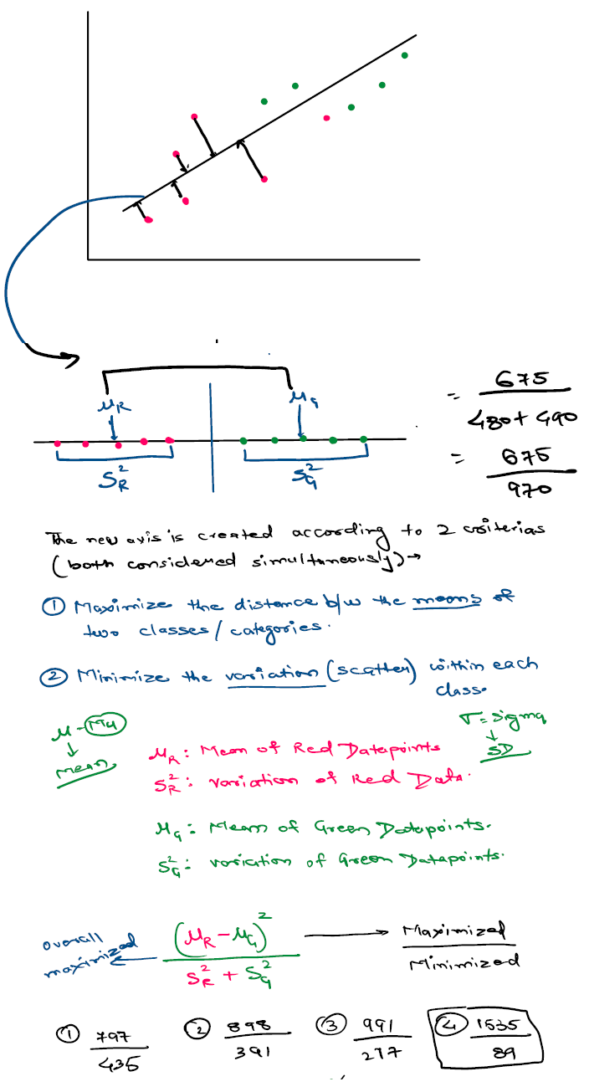

### Overview of LDA

1. **Classification**: LDA can be used as a classifier, predicting the class of a given input based on the linear combinations of features.
2. **Dimensionality Reduction**: LDA can also be used to reduce the dimensionality of the dataset while preserving as much of the class discriminatory information as possible.

### How LDA Works

* **Compute the mean vectors**: Calculate the mean vectors for each class.
* **Compute the within-class scatter matrix**: Sum the covariance matrices of each class.
* **Compute the between-class scatter matrix**: Calculate the covariance of the mean vectors.
* **Compute the eigenvectors and eigenvalues**: Solve the generalized eigenvalue problem for the scatter matrices.
* **Select the top eigenvectors**: Choose the eigenvectors corresponding to the largest eigenvalues to form a transformation matrix.
* **Transform the data**: Project the data onto the new feature space using the transformation matrix.

## PCA vs LDA

| **Aspect** | **PCA** | **LDA** |
| --- | --- | --- |
| Type | Unsupervised | Supervised |
| Objective | Maximize variance | Maximize class separability |
| Data Utilization | Uses all data to find principal components | Uses class labels to find discriminant axes |
| Scatter Matrix | Covariance matrix | Within-class and between-class scatter matrices |
| Applications | Data compression, noise reduction, visualization | Classification, dimensionality reduction, visualization |
| Dimensionality | Can reduce to any number of dimensions | Can reduce to (number of classes - 1) dimensions |

# 13th July

## Covariance

Covariance is a statistical measure that indicates the extent to which two variables change together. It is used to determine the relationship between two variables and whether they tend to increase or decrease simultaneously.

Here are some key points about covariance:

1. **Positive Covariance**: If the covariance is positive, it means that as one variable increases, the other variable tends to increase as well. Similarly, if one variable decreases, the other variable tends to decrease.
2. **Negative Covariance**: If the covariance is negative, it indicates that as one variable increases, the other variable tends to decrease, and vice versa.
3. **Zero Covariance**: If the covariance is close to zero, it suggests that there is no linear relationship between the variables.

The formula for covariance between two variables X and Y is:

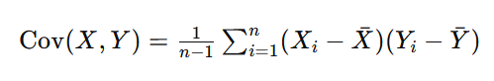

where:

* Xi​ and Yi​ are the individual data points.
* Xˉ and Yˉ are the means of the X and Y data sets, respectively.
* n is the number of data points.

Covariance is a measure used in varius fields such as finance (to measure how two stocks move together), machine learning, and data analysis. However, it is important to note that covariance is sensitive to the scale of the variables. To address this, the correlation coefficient is often used, which normalizes the covariance by the product of the standard deviations of the variables, resulting in a dimensionless measure that ranges between -1 and 1.

## Eigenvalues and Eigenvectors in PCA

Ex to understand :

if a vehicle moving to east side with a speed of 60 KMPH then

--> eigen value is 60 KMPH

--> eigen vector is east side

Principal Component Analysis (PCA) is a technique used to reduce the dimensionality of data while preserving as much variability as possible. Eigenvalues and eigenvectors play a crucial role in PCA. Here's a simple explanation of how they are used:

### Step-by-Step Explanation

1. **Data Preparation**:
   * Start with a dataset that has multiple features (variables).
   * Standardize the data (mean = 0 and variance = 1 for each feature) to ensure that each feature contributes equally to the analysis.
2. **Covariance Matrix**:
   * Compute the covariance matrix of the standardized data. This matrix shows how each pair of features varies together.
3. **Eigenvalues and Eigenvectors**:
   * Calculate the eigenvalues and eigenvectors of the covariance matrix.
   * **Eigenvectors**: These represent the directions of the new feature space. Each eigenvector is a principal component.
   * **Eigenvalues**: These indicate the amount of variance captured by each eigenvector (principal component). A higher eigenvalue means that the corresponding eigenvector captures more of the data’s variability.
4. **Sorting**:
   * Sort the eigenvalues and their corresponding eigenvectors in descending order of eigenvalues. This way, the first principal component will capture the most variance, the second will capture the next most, and so on.
5. **Dimensionality Reduction**:
   * Select the top kkk eigenvectors (principal components) based on their eigenvalues. This choice is often made by deciding how much of the total variance you want to retain (e.g., 95%).
   * Transform the original data to this new feature space using these top kkk eigenvectors. The resulting data set will have kkk features instead of the original number.

### Example

* **Original Data**:
  + Imagine you have a dataset with 3 features (like height, weight, and age).
* **Standardization**:
  + Standardize the data so that each feature has a mean of 0 and a variance of 1.
* **Covariance Matrix**:
  + Calculate the covariance matrix, which might look like this:

( 1.0 0.5 0.3

0.5 1.0 0.4

0.3 0.4 1.0 )

* **Eigenvalues and Eigenvectors**:
* Compute the eigenvalues and eigenvectors of this covariance matrix. Suppose the eigenvalues are 1.5, 1.0, and 0.5.
* The eigenvectors might be:

( 0.6 0.7 0.4

0.5 −0.2 −0.8

0.6 −0.6 0.5 )

* **Sorting**:
* Sort the eigenvalues and eigenvectors. The eigenvector corresponding to the highest eigenvalue (1.5) captures the most variance, so it becomes the first principal component.
* **Dimensionality Reduction**:
* Choose the top 2 eigenvectors (if you want to reduce to 2 dimensions).
* Transform the original data into this new 2-dimensional space.

### Why This Matters

* **Data Visualization**: Reducing data to 2 or 3 dimensions makes it easier to visualize.
* **Noise Reduction**: By keeping only the components with the highest variance, you often reduce noise.
* **Computational Efficiency**: Working with fewer dimensions can make machine learning algorithms faster and more efficient.

In essence, in PCA, eigenvalues help you decide which directions (principal components) are the most important, and eigenvectors tell you what those directions are.

# 14th July

## Variance

In simple words variance is a how max the data is spread.

Variance in Artificial Intelligence and Machine Learning (AIML) refers to the variability of a model's predictions. It indicates how much the predictions for a given data point differ between different training sets. Variance measures how sensitive a model is to the specific data it was trained on. Here's a more detailed breakdown:

1. **Definition**: Variance is a metric that captures the amount by which the predictions of a model would change if it were trained on a different dataset. High variance means the model's predictions fluctuate significantly when trained on different data, while low variance means the predictions are relatively stable.
2. **Bias-Variance Tradeoff**: Variance is a key component of the bias-variance tradeoff, which is a fundamental concept in machine learning. The tradeoff describes the relationship between:
   * **Bias**: The error introduced by approximating a real-world problem, which may be complex, by a simplified model.
   * **Variance**: The error introduced by the model's sensitivity to the fluctuations in the training set. A good model aims to achieve a balance between bias and variance, minimizing the total error.
3. **Impact on Model Performance**:
   * **High Variance**: Models with high variance are typically **overfitted**. They perform well on the training data but poorly on new, unseen data because they capture noise and fluctuations in the training data.
   * **Low Variance**: Models with low variance are generally more **generalizable** and perform consistently across different datasets. However, if the variance is too low, the model might be underfitting, not capturing the underlying trends in the data.
4. **Examples**:
   * **High Variance Model**: A very complex model like a deep neural network with many layers might have high variance if not properly regularized.
   * **Low Variance Model**: A simple linear regression model might have low variance but could potentially have high bias if the true relationship is non-linear.
5. **Reducing Variance**: Techniques to reduce variance in models include:
   * **Cross-validation**: Using k-fold cross-validation to ensure that the model's performance is consistent across different subsets of the data.
   * **Regularization**: Applying regularization techniques such as L1 (Lasso) or L2 (Ridge) regularization to penalize large coefficients and prevent overfitting.
   * **Ensemble Methods**: Combining predictions from multiple models (e.g., bagging, boosting) to reduce the variance of the final prediction.

Understanding and managing variance is crucial for building robust and reliable machine learning models that perform well on new, unseen data.

## Classification Report

A classification report provides a comprehensive summary of the performance of a classification model. It typically includes metrics such as precision, recall, F1-score, and support for each class.

### Generating a Classification Report

First, ensure you have the necessary libraries installed. If not, you can install scikit-learn using:

pip install scikit-learn

Then, you can generate a classification report as follows:

from sklearn.metrics import classification_report

# Assume y_test are the true labels and y_pred are the predicted labels

y_test = [0, 1, 2, 2, 0, 1]

y_pred = [0, 2, 1, 2, 0, 1]

report = classification_report(y_test, y_pred)

print(report)

### Example Output

Here’s an example of what the output might look like:

precision recall f1-score support

0 0.67 1.00 0.80 2

1 0.50 0.50 0.50 2

2 1.00 0.50 0.67 2

accuracy 0.67 6

macro avg 0.72 0.67 0.66 6

weighted avg 0.72 0.67 0.66 6

### Interpretation

1. **Precision**: The number of true positive results divided by the number of all positive results (true positive + false positive). It measures the accuracy of the positive predictions.

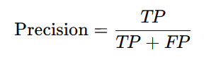

* + Example: For class 0, precision is 0.67, meaning 67% of the items predicted as class 0 were actually class 0.

1. **Recall (Sensitivity)**: The number of true positive results divided by the number of positive samples. It measures the ability of the model to find all the relevant cases within a dataset.

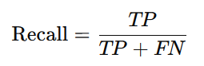

* + Example: For class 0, recall is 1.00, meaning the model found all actual class 0 samples.

1. **F1-Score**: The harmonic mean of precision and recall. It gives a balance between precision and recall.

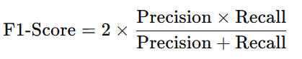

* + Example: For class 0, the F1-score is 0.80.

1. **Support**: The number of actual occurrences of the class in the dataset.
   * Example: For class 0, support is 2, meaning there are 2 actual instances of class 0 in the dataset.
2. **Accuracy**: The ratio of correctly predicted instances to the total instances.

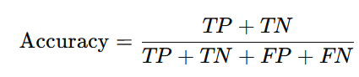

* + Example: Accuracy is 0.67, meaning the model correctly predicted 67% of the instances.

1. **Macro Average**: The unweighted mean of the precision, recall, and F1-score for each class. It does not consider the class imbalance.
   * Example: The macro average F1-score is 0.66.
2. **Weighted Average**: The mean of the precision, recall, and F1-score weighted by the number of true instances for each class. It considers class imbalance.
   * Example: The weighted average F1-score is 0.66.

### Full Code Example

Here’s a complete example including the model training part:

from sklearn.datasets import load_iris

from sklearn.model_selection import train_test_split

from sklearn.ensemble import RandomForestClassifier

from sklearn.metrics import classification_report

# Load dataset

data = load_iris()

X = data.data

y = data.target

# Split the dataset into training and testing sets

X_train, X_test, y_train, y_test = train_test_split(X, y, test_size=0.3, random_state=42)

# Train a classifier

clf = RandomForestClassifier(random_state=42)

clf.fit(X_train, y_train)

# Predict the labels for the test set

y_pred = clf.predict(X_test)

# Generate and print the classification report

report = classification_report(y_test, y_pred)

print(report)

This example demonstrates loading the Iris dataset, splitting it into training and testing sets, training a Random Forest classifier, making predictions, and generating a classification report to evaluate the model's performance.

## Confusion Matrix

A confusion matrix is a table used to evaluate the performance of a classification model. It summarizes the number of correct and incorrect predictions broken down by each class. This matrix provides insight into not only the accuracy of a model but also the types of errors it is making.

### Structure of a Confusion Matrix

For a binary classification problem, the confusion matrix has a 2x2 structure:

|  |  |  |
| --- | --- | --- |
|  | Predicted Positive | Predicted Negative |
| Actual Positive | TP | FN |
| Actual Negative | FP | TN |

* **TP (True Positive)**: The model correctly predicted the positive class.
* **FN (False Negative)**: The model incorrectly predicted the negative class for an actual positive instance.
* **FP (False Positive)**: The model incorrectly predicted the positive class for an actual negative instance.
* **TN (True Negative)**: The model correctly predicted the negative class.

Note:

For a multi-class classification problem (i.e. n problems/column), the confusion matrix extends to an **NxN** matrix, where N is the number of classes.

## Precision

It explain the correct true prediction ratio

Precision is a metric used to evaluate the performance of a classification model, particularly in binary classification. It measures the accuracy of the positive predictions made by the model. Precision is defined as the ratio of true positive (TP) predictions to the total number of positive predictions (both true positives and false positives (FP)).

### Formula

The formula for precision is:



### Interpretation

* **High Precision**: Indicates that the model has a low false positive rate, meaning it makes very few mistakes when predicting the positive class.
* **Low Precision**: Indicates that the model has a high false positive rate, meaning it often incorrectly predicts the positive class.

### Summary

Precision is particularly important in scenarios where the cost of false positives is high. For example, in spam detection, a high precision means that the emails classified as spam are indeed spam, reducing the chance of legitimate emails being incorrectly marked as spam.

## Recall

Recall, also known as **sensitivity** or **true positive rate**, is a metric used to evaluate the performance of a classification model. It measures the ability of the model to correctly identify all relevant instances of the positive class. Recall is particularly important in scenarios where it is crucial to capture as many positive instances as possible, even if it means having more false positives.

### Formula

The formula for recall is:



### Interpretation

* **High Recall**: Indicates that the model correctly identifies a high proportion of actual positives, meaning it misses few positive instances.
* **Low Recall**: Indicates that the model misses a significant number of actual positives.

Recall is particularly important in scenarios where missing a positive instance has a high cost. For example, in medical diagnosis, a high recall means that most patients with the disease are correctly identified, which is crucial for early treatment.

### Summary

Recall is a crucial metric for evaluating the performance of classification models, especially in cases where it is important to identify as many positive instances as possible. Understanding and optimizing for recall is essential in domains such as healthcare, fraud detection, and any field where missing positive instances carries significant consequences.

## Accuracy

Accuracy is a common metric used to evaluate the performance of a classification model. It measures the proportion of correct predictions (both true positives and true negatives) out of the total number of predictions made. Accuracy is simple to understand and compute, but it may not always be the best metric, especially in cases of imbalanced datasets.

### Formula

The formula for accuracy is:



### Interpretation

* **High Accuracy**: Indicates that the model makes correct predictions most of the time.
* **Low Accuracy**: Indicates that the model makes incorrect predictions frequently.

### Summary

Accuracy is a straightforward and widely used metric for evaluating the performance of classification models. While it provides a quick snapshot of how well a model is performing, it is important to consider other metrics such as precision, recall, and F1-score, especially when dealing with imbalanced datasets. Using multiple evaluation metrics helps to get a more comprehensive understanding of the model's performance.

# 20th July

Hands on Session on LDA

# 21st July

Hand on the Netflix project

# 27th July

## Time Series Data

Time series data is a sequence of data points collected or recorded at successive points in time, often at equally spaced intervals. This type of data captures the changes in values of a variable over time, making it crucial for analyzing trends, patterns, and forecasting future values.

Key characteristics of time series data include:

1. **Temporal Ordering**: The data points are ordered chronologically.
2. **Equidistant Intervals**: The measurements are usually taken at regular time intervals, such as daily, monthly, or annually.
3. **Dependency**: Current values can depend on past values, which is a critical aspect for analysis.

**Examples of Time Series Data:**

* Stock prices recorded daily.
* Monthly sales revenue of a company.
* Daily temperature readings.
* Hourly website traffic.

**Uses of Time Series Data:**

* **Forecasting**: Predicting future values based on past trends, like weather forecasting or stock market prediction.
* **Seasonality Analysis**: Identifying repeating patterns over time, such as higher ice cream sales in summer.
* **Trend Analysis**: Understanding long-term movements or trends, like an upward trend in sales over several years.
* **Anomaly Detection**: Identifying unusual patterns or outliers, such as sudden drops in website traffic.

**Methods for Analyzing Time Series Data:**

* **Moving Averages**: Smoothing out short-term fluctuations to identify longer-term trends.
* **Exponential Smoothing**: Applying weighted averages where more recent data points are given more significance.
* **ARIMA (AutoRegressive Integrated Moving Average)**: Combining autoregression, differencing, and moving averages to model and forecast time series data.
* **Seasonal Decomposition of Time Series (STL)**: Decomposing the data into seasonal, trend, and residual components.

Understanding and analyzing time series data is essential for making informed decisions in various fields, including finance, economics, environmental science, and business analytics.

### Data Patterns

Time series data can exhibit various patterns that help in understanding the underlying structure and making accurate forecasts. The primary patterns include:

1. **Trend**: A long-term movement or direction in the data, which can be upward, downward, or flat. Trends indicate the overall direction of the data over a significant period.
   * **Upward Trend**: When the data shows a general increase over time.
   * **Downward Trend**: When the data shows a general decrease over time.
   * **No Trend**: When the data fluctuates around a constant level without a clear direction.
2. **Seasonality**: Regular, repeating patterns or cycles in the data that occur at specific intervals, such as daily, weekly, monthly, or yearly. Seasonal patterns are influenced by seasonal factors, such as holidays or weather conditions.
   * **Example**: Increased retail sales during the holiday season every year.
3. **Cyclic Patterns**: Long-term fluctuations that are not of fixed frequency, often associated with economic or business cycles. Unlike seasonality, cyclic patterns do not have a fixed period and can vary in length.
   * **Example**: Economic booms and recessions.
4. **Irregular/Random Patterns**: Unpredictable, random variations that do not follow any specific trend, seasonality, or cyclic pattern. These are often caused by unexpected events or noise in the data.
   * **Example**: Sudden spikes in sales due to a viral marketing campaign.
5. **Stationarity**: A property of time series data where the statistical properties (mean, variance, autocorrelation) do not change over time. Stationary data does not exhibit trends or seasonality.
   * **Non-stationary Data**: Data with trends, seasonality, or other patterns that change over time.
   * **Stationary Data**: Data where fluctuations occur around a constant mean and variance.
6. **Autocorrelation**: The correlation of a time series with its own past values. High autocorrelation indicates that past values have a strong influence on current values.
   * **Lag**: The interval at which the correlation is measured. For example, a lag of 1 means correlating the time series with its immediately previous value.

**Identifying and understanding these patterns is crucial for effective time series analysis and forecasting. Techniques such as decomposition, differencing, and various statistical tests (like the Augmented Dickey-Fuller test for stationarity) are used to analyze and model these patterns.**

### Rolling Mean

A rolling mean, also known as a moving average, is a statistical method used to analyze time series data by calculating the average of data points over a specified number of periods, which rolls or moves through the data set. This technique helps smooth out short-term fluctuations and highlight longer-term trends or cycles.

#### Types of Rolling Mean

1. **Simple Moving Average (SMA)**:
   * The average of a fixed number of consecutive periods.
   * As each new data point becomes available, the oldest data point is dropped, and the newest one is added.
2. **Exponential Moving Average (EMA)**:
   * Places more weight on recent data points, making it more responsive to recent changes.
   * Formula: EMA(t)=α⋅yt+(1−α)⋅EMA(t−1)\text{EMA}(t) = \alpha \cdot y_t + (1 - \alpha) \cdot \text{EMA}(t-1)EMA(t)=α⋅yt​+(1−α)⋅EMA(t−1)
     + α\alphaα: Smoothing factor, 0<α<10 < \alpha < 10<α<1

#### Purpose and Applications

* **Trend Analysis**: Helps identify the underlying trend by smoothing out the noise.
* **Forecasting**: Used as a basis for more complex forecasting models.
* **Anomaly Detection**: Helps detect outliers by comparing actual values against the rolling mean.
* **Signal Processing**: Used in technical analysis of financial markets to identify buy/sell signals.

### Rolling Standard Deviation

A rolling standard deviation, also known as a moving standard deviation, is a statistical method used to measure the variability or dispersion of a set of data points over a specified number of periods, which moves through the data set. This technique helps to analyze the stability or volatility of a time series by smoothing out short-term fluctuations and highlighting longer-term patterns.

#### Purpose and Applications

* **Volatility Analysis**: Commonly used in financial markets to measure the volatility of asset prices.
* **Risk Management**: Helps in understanding and managing the risk associated with time series data.
* **Quality Control**: Used in manufacturing and other industries to monitor the stability of processes.

#### Calculation

To calculate the rolling standard deviation, follow these steps:

1. **Select Window Size (n)**: Choose the number of periods over which the standard deviation will be calculated.
2. **Calculate Mean**: Compute the rolling mean for the selected window size.
3. **Compute Variance**: Calculate the variance for each window by taking the average of the squared differences between each data point and the rolling mean.
4. **Take Square Root**: The rolling standard deviation is the square root of the variance.

##### Example

Consider a time series representing daily stock prices over 10 days:

| **Day** | **Price** |
| --- | --- |
| 1 | 100 |
| 2 | 102 |
| 3 | 101 |
| 4 | 105 |
| 5 | 107 |
| 6 | 110 |
| 7 | 108 |
| 8 | 112 |
| 9 | 115 |
| 10 | 118 |

To calculate a 3-day rolling standard deviation:

* **Day 3**:
  + Mean: (100+102+101)/3=101
  + Variance: ((100−101)^2+(102−101)^2+(101−101)^2) / 3=0.6667
  + Std: sqrt(0.6667) ≈ 0.82 (≈ means ‘ approx. equal value)
* **Day 4**:
  + Mean: (102+101+105)/3=102.67
  + Variance: ((102−102.67)^2+(101−102.67)^2+(105−102.67)^2)/3=2.89
  + Std: sqrt(2.89) ≈ 1.7
* **Day 5**:
* Mean: (101+105+107)/3=104.33
* Variance: ( (101-104.33)^2 + (105-104.33)^2 + (107-104.33)^2 ) / 3 = 6.22
* Std: sqrt(6.22) ≈ 2.49

This process continues for the entire series, providing a smoothed line that shows how the variability of the data changes over time.

### ARIMA model

The ARIMA (AutoRegressive Integrated Moving Average) model is a popular statistical method used for analyzing and forecasting time series data. It combines three components—autoregression (AR), differencing (I for Integrated), and moving average (MA)—to model the data. ARIMA models are particularly useful for non-stationary data that can be made stationary through differencing.

#### Components of ARIMA

1. **Autoregressive (AR) Component**:
   * Refers to a model that uses the dependency between an observation and a number of lagged observations (previous time steps).
   * AR(p): The order of the autoregressive part indicates the number of lagged observations included in the model.
2. **Integrated (I) Component**:
   * Refers to the differencing of raw observations to make the time series stationary.
   * I(d): The order of differencing needed to make the series stationary.
3. **Moving Average (MA) Component**:
   * Refers to a model that uses dependency between an observation and a residual error from a moving average model applied to lagged observations.
   * MA(q): The order of the moving average part indicates the number of lagged forecast errors included in the model.

#### ARIMA Model Notation

The ARIMA model is typically denoted as ARIMA(p, d, q), where:

* p is the order of the autoregressive part.
* d is the order of differencing.
* q is the order of the moving average part.

#### Steps to Build an ARIMA Model

1. **Identification**:
   * Determine the order of differencing needed to make the series stationary (d).
   * Use **autocorrelation function** (ACF) and **partial autocorrelation function** (PACF) plots to identify potential values for p and q.
2. **Estimation**:
   * Estimate the parameters ϕ (phi) and θ (theta) using methods like maximum likelihood estimation.
3. **Diagnostic Checking**:
   * Check the residuals of the model to ensure they resemble white noise (i.e., no patterns or correlations).
   * Use statistical tests like the Ljung-Box test.
4. **Forecasting**:
   * Once the model is validated, use it to make forecasts for future time periods.

#### Example

Suppose you have monthly sales data for a retail store and you want to forecast future sales. After differencing the data once (d = 1) to make it stationary, you analyze the ACF and PACF plots and decide on an ARIMA(2, 1, 1) model.

1. **Autoregressive part (p = 2)**: The model includes sales from the previous two months.
2. **Differencing (d = 1)**: The data has been differenced once to achieve stationarity.
3. **Moving Average part (q = 1)**: The model includes the error term from the previous month.

#### Benefits of ARIMA

* **Versatility**: Can model a wide range of time series data.
* **Stationarity**: Can handle non-stationary data through differencing.
* **Forecasting**: Provides a robust framework for making accurate forecasts.

By understanding and applying ARIMA models, you can effectively analyze time series data and make informed predictions.

### Adfuller Test

The Augmented Dickey-Fuller (ADF) test is a statistical test used to determine whether a time series is stationary or has a unit root, which indicates non-stationarity. Stationarity is an important property in time series analysis, as many statistical models assume that the underlying data generating process is stationary.

The ADF test is an extension of the Dickey-Fuller test and includes lagged differences of the time series to account for higher-order autocorrelation. It tests the null hypothesis that a unit root is present in an autoregressive model.

#### Key Concepts

1. **Stationarity**: A time series is stationary if its statistical properties, such as mean and variance, are constant over time. Non-stationary time series often exhibit trends, seasonality, or changing variances.
2. **Unit Root**: A time series that has a unit root is non-stationary. The presence of a unit root indicates that the series follows a random walk and may have a stochastic trend.

#### Test Statistics

The ADF test statistic is compared against critical values to determine whether the null hypothesis (presence of a unit root) can be rejected. The null hypothesis is:

* **Null Hypothesis (H₀)**: The time series has a unit root (i.e., it is non-stationary).
* **Alternative Hypothesis (H₁)**: The time series does not have a unit root (i.e., it is stationary).

#### Steps to Perform the ADF Test

1. **Specify the Model**: Choose between different models (with or without a constant, trend, or both) based on the characteristics of the time series.
2. **Estimate the Test Statistic**: Apply the ADF test to compute the test statistic and corresponding p-value.
3. **Compare with Critical Values**: Compare the test statistic with critical values from the ADF test table to determine whether to reject the null hypothesis.
4. **Interpret Results**: If the test statistic is less than the critical value (or the p-value is below the significance level, typically 0.05), reject the null hypothesis and conclude that the time series is stationary. Otherwise, fail to reject the null hypothesis.

#### Example

Suppose you have a time series of monthly sales data and want to test for stationarity. You perform the ADF test and obtain the following results:

* **ADF Test Statistic**: -3.45
* **Critical Value (1% level)**: -3.50
* **p-value**: 0.08

In this case:

* The ADF test statistic (-3.45) is greater than the critical value (-3.50), so you fail to reject the null hypothesis at the 1% significance level.
* The p-value (0.08) is greater than 0.05, so you also fail to reject the null hypothesis at the 5% significance level.

This suggests that the time series may be non-stationary and may require differencing or other transformation to achieve stationarity.

#### Summary

The Augmented Dickey-Fuller test is a valuable tool for assessing the stationarity of time series data, which is crucial for selecting appropriate statistical models and making reliable forecasts.

# 28th July

We have hands-on session on TimeSeries including Transformation, differentials, Boxcox, AR, ARIMA, SARIMA.

# 3rd August

We have continued hands-on session.

### ACF(q) vs PACF(p)

In time series analysis, **Autocorrelation Function (ACF)** and **Partial Autocorrelation Function (PACF)** are essential tools for understanding the underlying structure of the data. Here's a brief overview of each:

#### 1. **Autocorrelation Function (ACF)**

* **Definition:** The ACF measures the correlation between the time series and its lagged values at different lags. Essentially, it tells us how well the present value of the series is related to its past values.
* **Use:** ACF is used to identify the overall correlation structure of the data. It helps to determine the number of lags that significantly contribute to the time series' behavior.
* **Interpretation:**
  + A high ACF value at a particular lag suggests that the values in the time series are significantly correlated with each other at that lag.
  + If the ACF declines slowly, this could indicate that the series is non-stationary.
  + A sharp cut-off after a few lags suggests a moving average (MA) component.

#### 2. **Partial Autocorrelation Function (PACF)**

* **Definition:** The PACF measures the correlation between the time series and its lagged values, but with the influence of the intermediate lags removed. It represents the "pure" correlation between the series and its lagged version.
* **Use:** PACF is particularly useful in identifying the order of an autoregressive (AR) model. It helps determine the number of autoregressive terms (lags) to include in the model.
* **Interpretation:**
  + A significant PACF value at a particular lag indicates that the lag contributes to the series independently of the intermediate lags.
  + A sharp drop in PACF after a certain lag suggests that an autoregressive process of that order might be suitable.

#### **Usage in Machine Learning**

* In the context of machine learning, ACF and PACF are commonly used in **ARIMA models** (AutoRegressive Integrated Moving Average) for forecasting. The ACF helps identify the order of the MA (Moving Average) part, while the PACF helps identify the order of the AR (AutoRegressive) part.
* They are also used to understand the temporal dependencies in time series data, which can be crucial for feature engineering or model selection in more complex models like **LSTMs** or **transformer-based** models for time series forecasting.

Understanding the ACF and PACF can help you better model and forecast time series data by giving insights into the dependencies within the data.

# 4th August

Today also we have hands on method on TimeSeries Data by using AirPassengers.csv

### **Decomposition**

In time series analysis, **decomposition** refers to breaking down a time series into its fundamental components to better understand its underlying structure and characteristics. Decomposition is particularly useful for analyzing and forecasting time series data, as it allows you to separate out different sources of variation.

#### Key Components of Time Series Decomposition

1. **Trend (T)**:
   * The trend component represents the long-term progression or direction in the data. It shows the general movement of the time series over a longer period, which could be upward, downward, or flat.
   * Example: In a time series of sales data, the trend might show a gradual increase in sales over several years.
2. **Seasonality (S)**:
   * The seasonality component captures the repeating patterns or cycles in the data that occur at regular intervals (e.g., daily, monthly, yearly).
   * Example: Retail sales often spike during the holiday season each year, representing seasonal behavior.
3. **Residual/Noise (R)**:
   * The residual component (also called the noise or irregular component) represents the random variation or "leftover" part of the data that cannot be explained by the trend or seasonality.
   * This component includes all the irregularities and random noise in the data.
4. **Cyclic Component** (optional, sometimes part of trend):
   * Cycles are fluctuations that occur over longer periods than seasonality but are not necessarily regular like seasonal patterns. They often relate to economic or business cycles.

#### Types of Decomposition

1. **Additive Decomposition**:
   * In an additive model, the time series is assumed to be the sum of the trend, seasonality, and residual components.
   * **Use Case**: Additive decomposition is appropriate when the variations in the components are consistent over time.
2. **Multiplicative Decomposition**:
   * In a multiplicative model, the time series is assumed to be the product of the trend, seasonality, and residual components.
   * **Use Case**: Multiplicative decomposition is used when the components' variations change proportionally with the level of the series (e.g., higher values of the time series have larger fluctuations).

#### Use Cases of Decomposition

1. **Forecasting**: Helps in better understanding the time series and improving forecasting models by separately modeling trend and seasonality.
2. **Anomaly Detection**: Residuals from decomposition can highlight anomalies or unusual patterns not explained by trend or seasonality.
3. **Data Cleaning**: Decomposition can help remove seasonality or trends to analyze the underlying data more effectively.

By decomposing a time series, you can gain valuable insights into its structure, making it easier to analyze, interpret, and model.

# 10th Aug

Hands on session on Decision Trees

# 11th Aug

Hands on session on Random Forest

# 17th Aug

Hands on session on K-Means algorithm

# 18th Aug

Hands on session on LDA

## nlargest method

The nlargest() method in Python is a part of the heapq module and is used to find the n largest elements in a dataset. This method is particularly useful when you need the top n largest elements from an iterable, like a list, without sorting the entire dataset.

* df.nlargest(n, iterable, key=None)

Here,

* **n**: The number of largest elements you want to retrieve.
* **iterable**: The dataset from which to retrieve the largest elements.
* **key** *(optional)*: A function that serves as a key for sorting the elements. Similar to the key parameter in Python's sorted() function.

Ex1:

import heapq

numbers = [1, 8, 2, 23, 7, 5, 10]

# Get the 3 largest numbers

largest_numbers = heapq.nlargest(3, numbers)

print(largest_numbers) # Output: [23, 10, 8]

Ex2: Custom Key

import heapq

people = [

{'name': 'Alice', 'age': 30},

{'name': 'Bob', 'age': 25},

{'name': 'Charlie', 'age': 35},

{'name': 'Dave', 'age': 20}

]

# Get the 2 oldest people

oldest_people = heapq.nlargest(2, people, key=lambda x: x['age'])

print(oldest_people)

# Output: [{'name': 'Charlie', 'age': 35}, {'name': 'Alice', 'age': 30}]

**Use Cases:**

* Efficiently retrieving the largest n elements from large datasets.
* Avoiding the need to sort the entire dataset, which can be time-consuming.

This method is particularly useful in performance-critical applications where only the top elements are needed, and sorting the entire list is unnecessary.

# 24th August

Hand-on session on TimeSeries Data on Covid-19 data set

Guideline:

* Use Pandas to accumulate data from multiple data files
* Use plotly (Visualization Library) to create interactive visualizations.
* Use Facebook prophet library to make time series models.
* Visualize the prediction by combining these technologies.

# 31st August

Hands-on session Census income data set

# 1st Sep

Introduction session on Deep Learning

* From here the documentation will be on new document named with Deep Learning,
* Have to split this document into two parts for:
  + Python
  + ML